**Google drive link:**

[**https://drive.google.com/file/d/1fkuwN9owrRPj2YdCYLPywYqS0pdO4k-I/view?usp=sharing**](https://drive.google.com/file/d/1fkuwN9owrRPj2YdCYLPywYqS0pdO4k-I/view?usp=sharing)

**ONLINE BANK MANAGEMENT SYSTEM**

***Submitted in partial fulfillment of the requirements for the degree of***

**Bachelor of Technology**

**in**

**Computer Science and Engineering**

|  |  |
| --- | --- |
| **NAME** | **REG NO** |
| **AHMED SHIMELS** | **18BCE2427** |
| **ROZA KEFELEGN** | **18BCE2431** |

**Under the guidance of**

**Prof. Janani T**

**Slot-E1+TE1**

**CSE3002**

**School of Computer Science and Engineering**

 **VIT, Vellore.**

December 2022

DECLARATION

We hereby declare that the thesis entitled **Bank management system submitted** by us, for the award of the degree of Bachelor of Technology in Computer Science and Engineering to VIT is a record of bonafide work carried out by us under the supervision of Professor Janani T

I further declare that the work reported in this thesis has not been submitted and will not be submitted, either in part or in full, for the award of any other degree or diploma in this institute or any other institute or university.

Place: Vellore

Date: 9/12/22

Ahmed and Roza

Signature of the Candidate

**INDEX:**

|  |  |  |
| --- | --- | --- |
| **S NO** | **TITLE** | **PAGE NO** |
| **1** | **ABSTRACT** | 4 |
| **2** | **INTRODUCTION** | 5 |
| **3** | **SOFTWARE USED** | 6 |
| **4** | **WORKFLOW** | 8 |
| **5** | **MODULE WISE SPLIT UP** | 9 |
| **6** | **FRONTEND** | 10 |
| **7** | **BACKEND** | 16 |
| **8** | **SAMPLE CODE** | 18 |
| 9 | **CONCLUSION AND FUTURE PLAN** | 21 |
| 10 | **REFERENCE** | 28 |

1. **ABSTRACT**

Bank Account Management System is an application to maintain a personal bank account. In this project we have tried to demonstrate the effectiveness of the bank account system and cover the basic functionality of the Bank Management System. Develop a project to resolve customer financial requests in banking conditions to maximize the needs of the end-user by providing a variety of banking services. It also enables the user's work environment to have additional functionality that can be provided under a standard banking project. This project was developed to make processes easier and faster, which is not possible with manual programs, which are overcome by this software.

This project was developed using PHP, HTML language and the use of MYSQL database connections. The organization needs to be welldefined and manage needs to ensure that they meet the needs of the customer, while showing consistency and consistency and budget. The project analyzes the requirements of the plan and comes up with descriptions of the requirements. The plan is then designed according to specific details to meet the requirements. The program design is then implemented with MYSQL, PHP and HTML. The system is designed as a management system for content communication. The content management system deals with data entry, authentication is verified and updated when the interactive system interacts with system communications with management and users. Therefore, more features of this project will save transaction time and thus increase the efficiency of the system.

1. **Introduction.**

Moving on, this Bank Management System Project in PHP focuses mainly on internet banking. Also, the system displays all the lists of statements. In addition, the system allows managing bank accounts too. This project is divided into two categories: Staff and Customer. In an overview of this web application, the staff can simply manage pending accounts. Meaning all the registration forms are forwarded to the staff’s account where he/she must approve it for further process. The staff has the right to manage customers, search customers, and credit amounts to the customer’s account. Here, the depositing amount to the customer’s account refers to a credit amount to the customer.

In terms of management of the customers, the staff needs to enter the account numbers for each to make changes. And similar goes to searching the records. He/she must enter an account number for listing all the available information of the account. This includes name, id, gender, address, contact info, account details, remaining balance, PAN number, citizenship number, and so on. This way, the staff can view active customer’s accounts. And to credit the amount to a customer’s account, the user must enter an account number and amount to it. After a successful process, the customer can view their deposit statements from their accounts.

With access to the internet banking feature, the customer can perform important things. Just like the real internet banking feature, this project allows you to view your profile, change password, transfer funds, and view bank statements. The system displays all the account details on the home screen with an overview of recent banking activities. To transfer funds to another account, the customer should first add and link with beneficiary accounts. For this, the system asks for the beneficiary account name, account number, IFSC code, and account type. After adding it, the customer can simply select among the available beneficiary account and enter amounts with remarks. In addition, the user can list and remove beneficiary accounts too.

1. **Software/hardware tools used:**

HARDWARE REQUIREMENTS:

* System: Intel i3 core processor and above
* Hard Disk: 8GB
* Monitor: 14’ColorMonitor
* Mouse: Optical Mouse
* Operating system: Windows7/8/10

SOFTWARE REQUIREMENTS:

* Coding Language: JavaScript, Php, HTML, CSS, SQL
* Data Base: SQL Server 2014
* Tools: Visual studio code 2013, XAMPP sever
* Browser: Chrome, Firefox, Internet Explorer, Edge
  1. **Technical Specification**

1. Front-End Development Languages:
   * 1. CSS Cascading Style Sheets (CSS) is a style sheet language used for describing the presentation of document written in a markup language like HTML. CSS is designed to enable the separation of presentation and content, including layout, colors, and fonts. This separation can improve content accessibility, provide more flexibility and control in the specification of presentation characteristics, enable multiple web pages to share formatting by specifying the relevant CSS in a separate .css file, and reduce complexity and repetition in the structural content.
     2. HTML Hyper Text Markup Language (HTML) is the backbone of any website development process, without which a webpage doesn't exist. Hypertext means that text has links, termed hyperlinks, embedded in it. A markup language indicates text can be turned into images, tables, links, and other representations. It is the HTML code that provides an overall framework of how the site will look. HTML was developed by Tim Berners-Lee. The latest version of HTML is called HTML5 and was published on October 28, 2014, by the W3 recommendation. This version contains new and efficient ways of handling elements such as video and audio files.

ii. Server-Side Programming

* + 1. PHP Hypertext Preprocessor (or simply PHP) is a server-side scripting language designed for Web development. PHP code may be embedded into HTML code, or it can be used in combination with various web template systems, web content management systems, and web frameworks. PHP code is usually processed by a PHP interpreter implemented as a module in the web server or as a Common Gateway Interface (CGI) executable. The web server combines the results of the interpreted and executed PHP code, which may be any type of data, including images, with the generated web page. PHP code may also be executed with a command-line interface (CLI) and can be used to implement standalone graphical applications.
    2. MySQL MySQL is an open- source relational database management system (RDBMS). It is particularly useful in handling structured data where there are relations between different entities/variables of the data. It uses the standard SQL. MySQL is the de-facto standard database system for web sites with huge volumes of both data and end-users (like Facebook, Twitter, and Wikipedia). Another great thing about MySQL is that it can be scaled down to support embedded database applications

1. **Block diagram and project workflow:**

4.1. project workflow

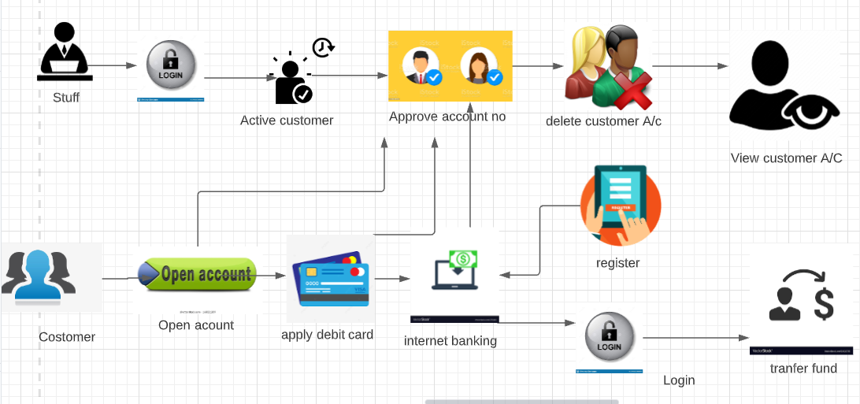

4.2.**ER diagram of the project:**

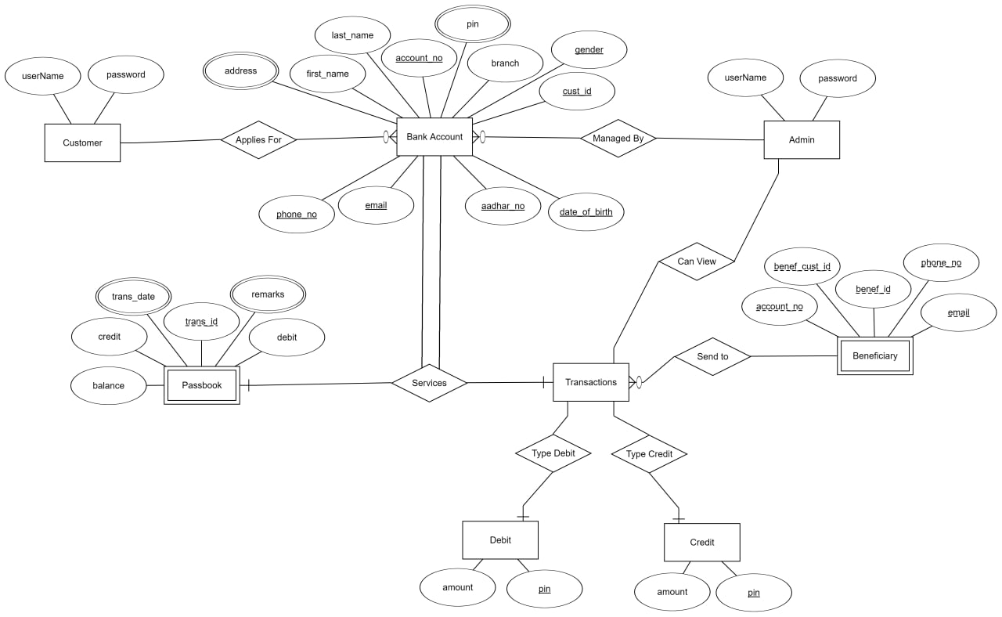

# Module wise split-up:

* Staff Panel
* Customer Panel
* Create Bank Account
* Manage Pending Accounts
* Apply for debit card
* Internet Banking Registration
* View Active Customers
* Manage Customer’s Account
* Search Customer’s Account
* Credit Customer’s Account/Deposit
* Bank Statements
* Fund Transfer
* Manage Beneficiary Accounts
* Change Password
* View Personal Account Details
* View Profile
  1. **Front End:**

Home page part:

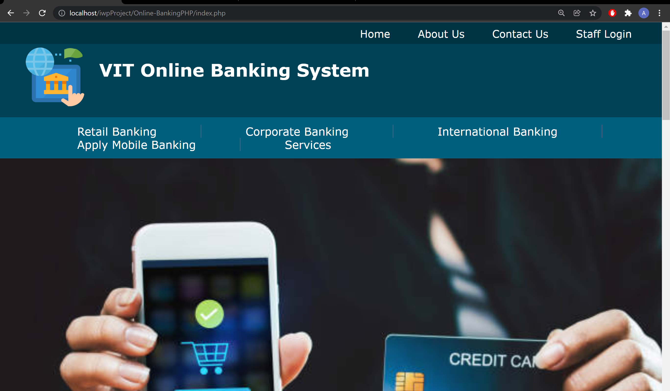

It consists of 4 parts accessible via a top navigation bar:

* ***Home***: The home page of the website, also the login page for the customer.
* ***News***: This page consists of news/notices posted by the admin on the website.
* ***Contact***: This page has contact information about the bank.

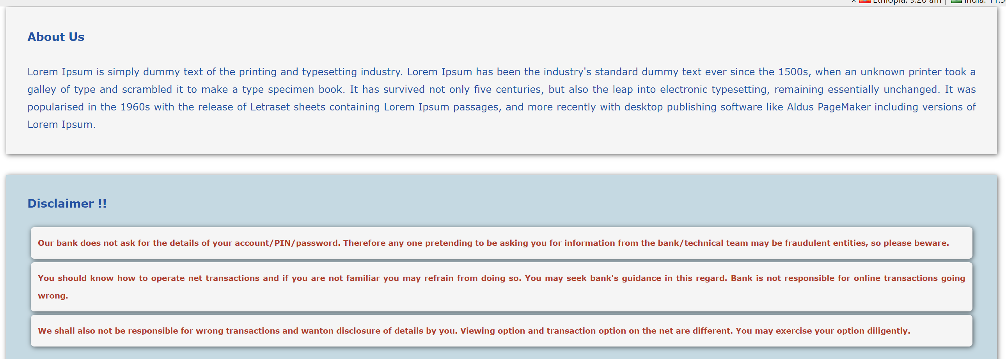

* ***About***: About the bank and info regarding the developers of the website is present on this page.

The customer part:

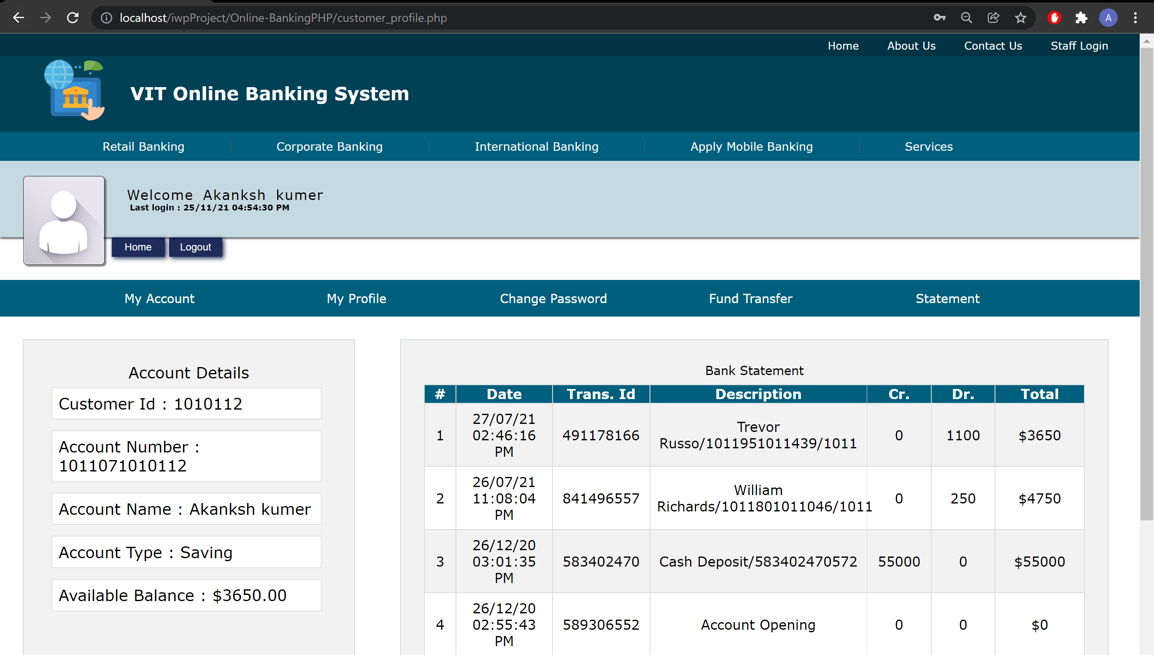

This part is only accessible after the customer logs into his/her account. It cannot be accessed in any other way.

It consists of the following core internet banking features, most of them accessible via a side pane:

* A ***Customer Home*** page which displays information about the customer like total balance, account number, last transaction, etc.
* A ***My Profile*** page in which the customer can view/edit non sensitive details/change password and/or pin, etc.

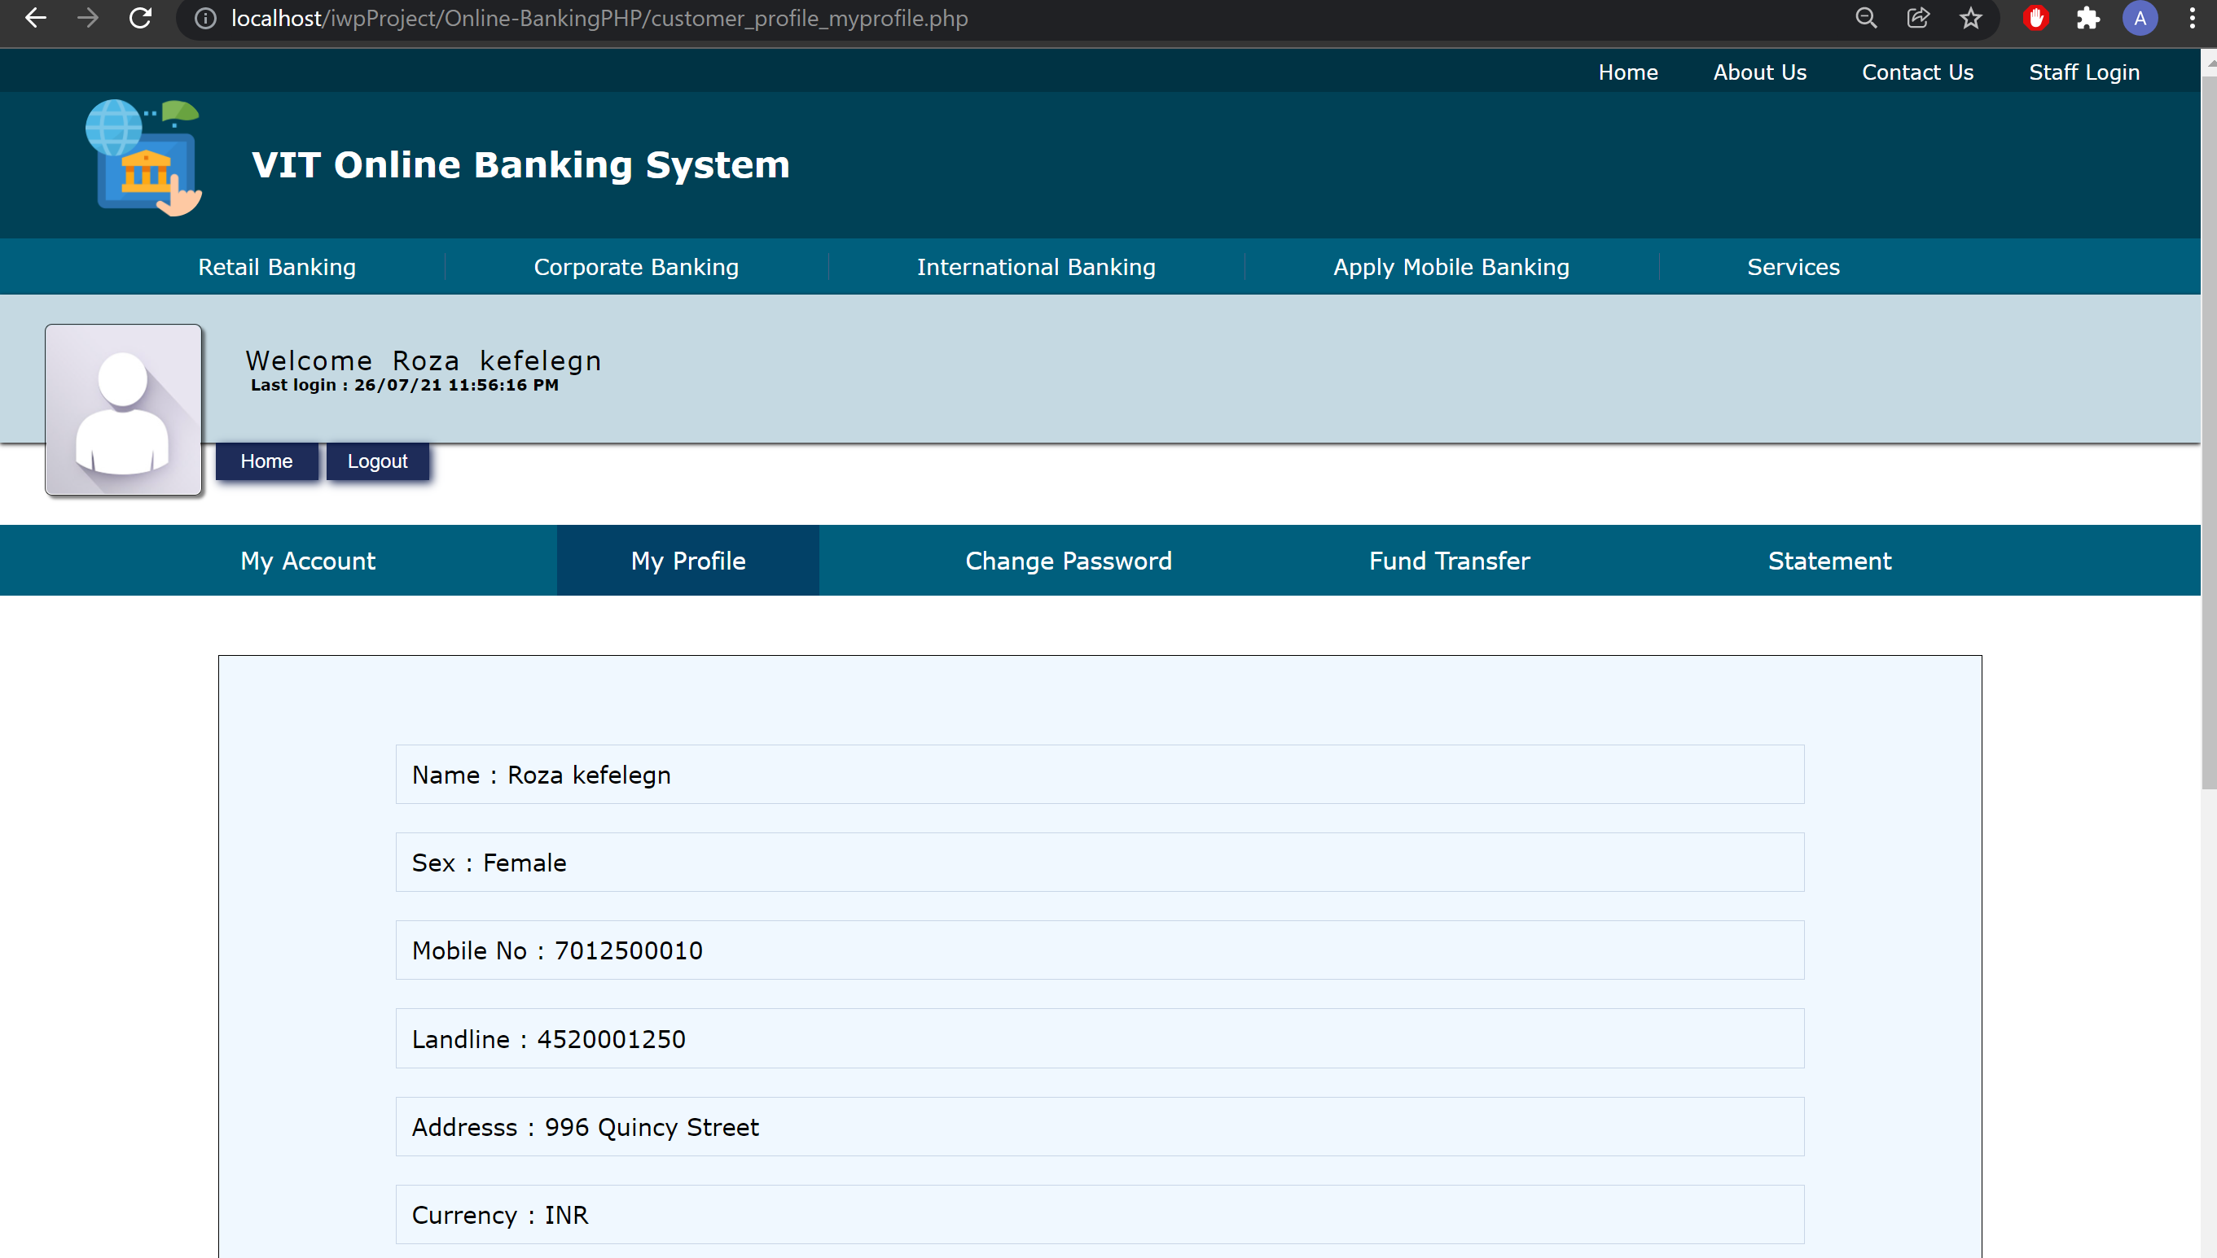

* A ***My Transactions*** page:

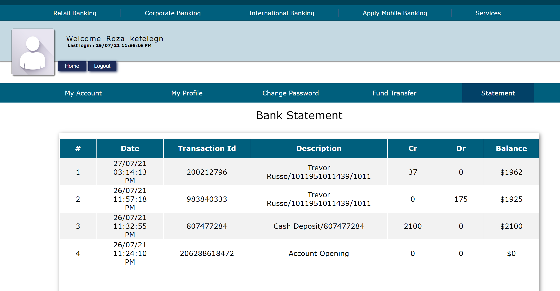

* which displays all the transactions of the customer in a tabular form. It consists of the following features:
  + Ability to sort the transactions by the transaction id or date of the transaction in both ascending and descending order.
  + Ability to filter the transactions based on a certain type of transaction/remark.
  + Ability to filter/display transactions within/from/up to a certain date range.
  + Ability to use one or more filter in conjugation with the other.
  + Ability to use filter in conjugation with sort type.
  + Filters being used are constantly displayed on the screen.
  + Ability to remove applied filters.
* The customer can transfer funds to another customer via a ***Transfer Funds*** page which has the following features:
  + Before the customer can send funds, the customer has to add beneficiaries to whom he/she can send the funds.
  + Beneficiaries can be added via the transfer funds page. To add a beneficiary, the customer has to fill all the valid details as required in the add beneficiary form. Submitting invalid information will result in rejection of the form and the beneficiary can’t be added.
  + Beneficiaries can only be added if and only if ALL the information entered is valid.
  + After a beneficiary has been successfully added it will be displayed in the transfer funds page.
  + The beneficiaries are displayed in a sequential card layout influenced by the material design. The customer can send funds to these beneficiaries or delete them.
  + The customer can search for a particular beneficiary among the list of his/her beneficiaries by both name and account number.
  + While transferring funds the customer must authenticate the transfer by his online banking password.
  + If the transfer is invalid like <0 or >customers account balances the transfer will be rejected and an appropriate message will be given to the customer.
  + An important feature is auto deletion of beneficiaries discussed on the next slide.

Auto deletion of beneficiaries:

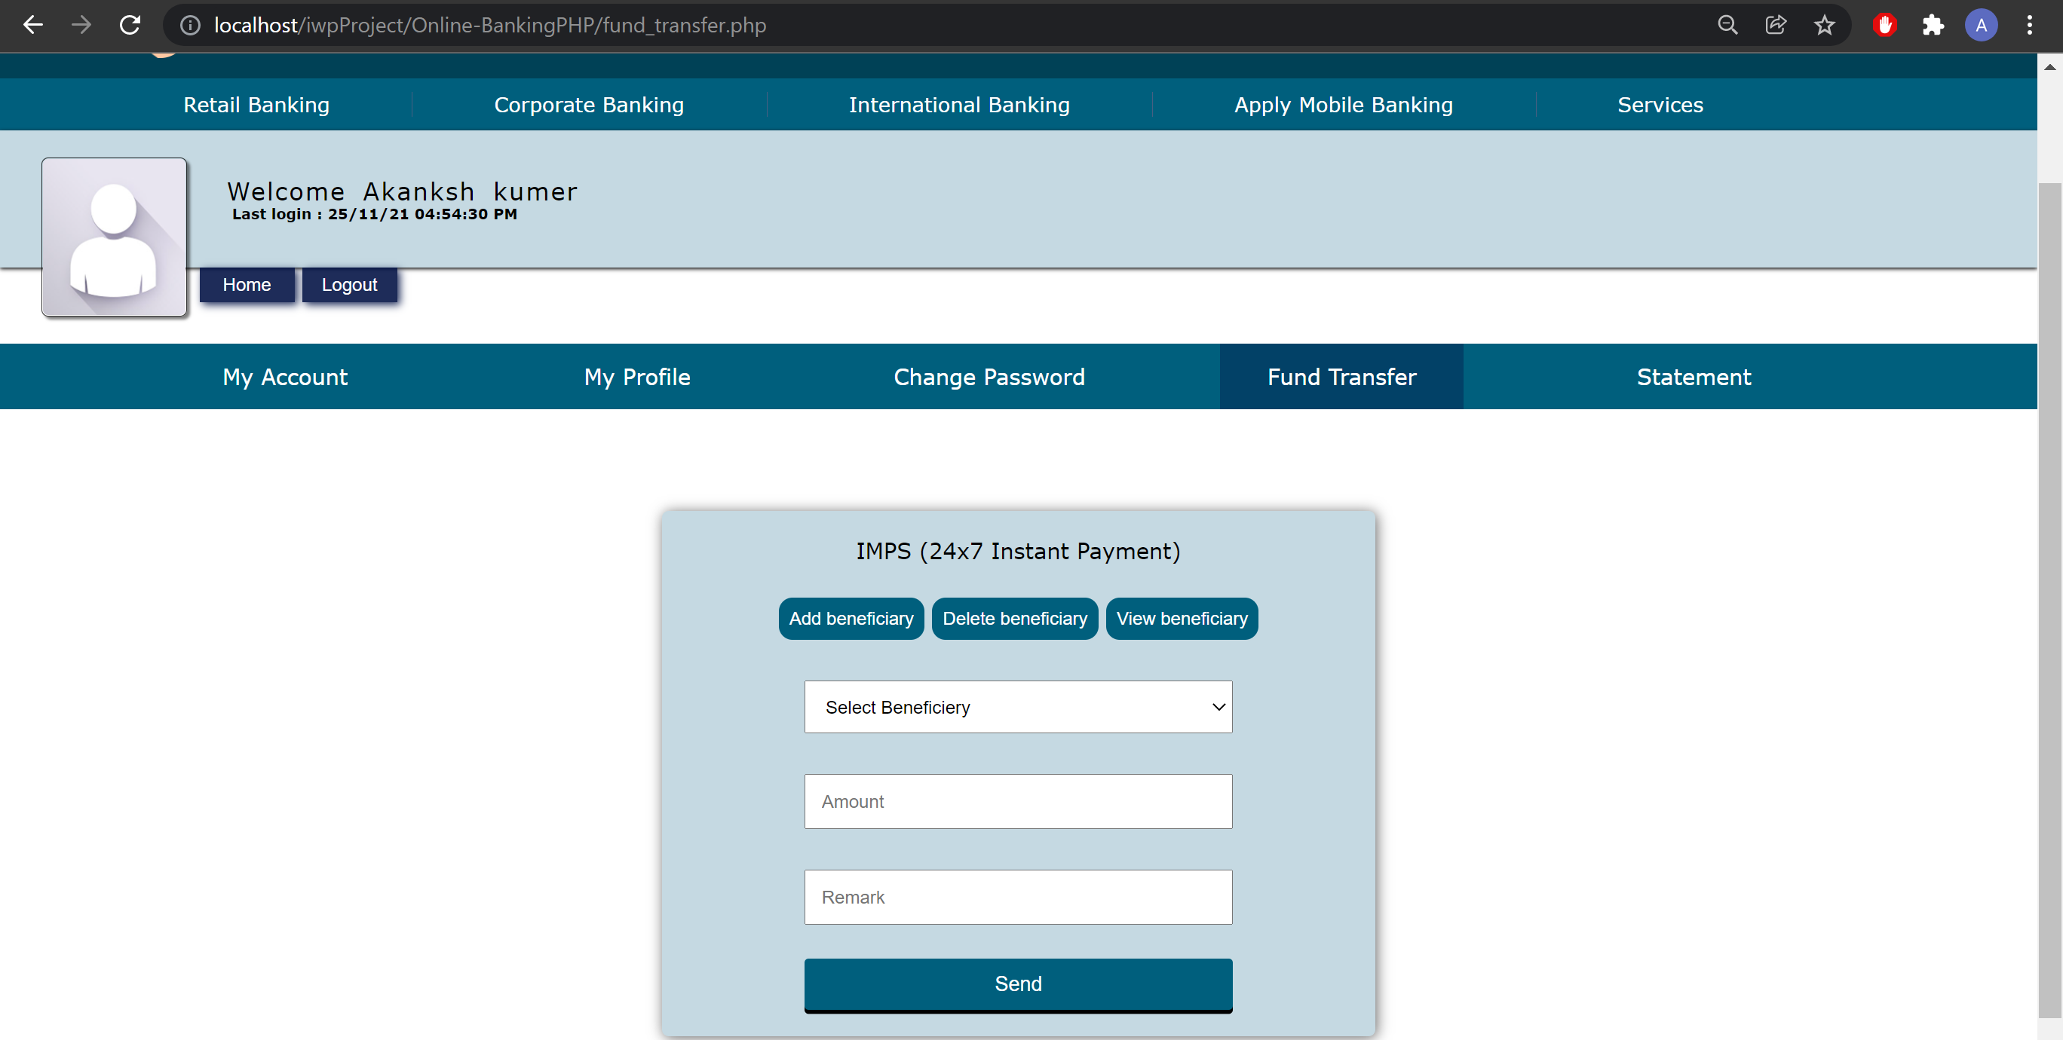

* Every time the “transfer funds” page loads a check is made initially to ensure that the data integrity of the beneficiaries is intact. If not, those beneficiaries whose data integrity has been compromised will be automatically deleted from the list of beneficiaries and an appropriate message will be displayed to the customer.
* Data integrity of a beneficiary will be lost if and only if the following data of the beneficiary is changed: email id, phone number, account number, name, and/or if the beneficiary’s account no longer exists.

The admin/stuff part:

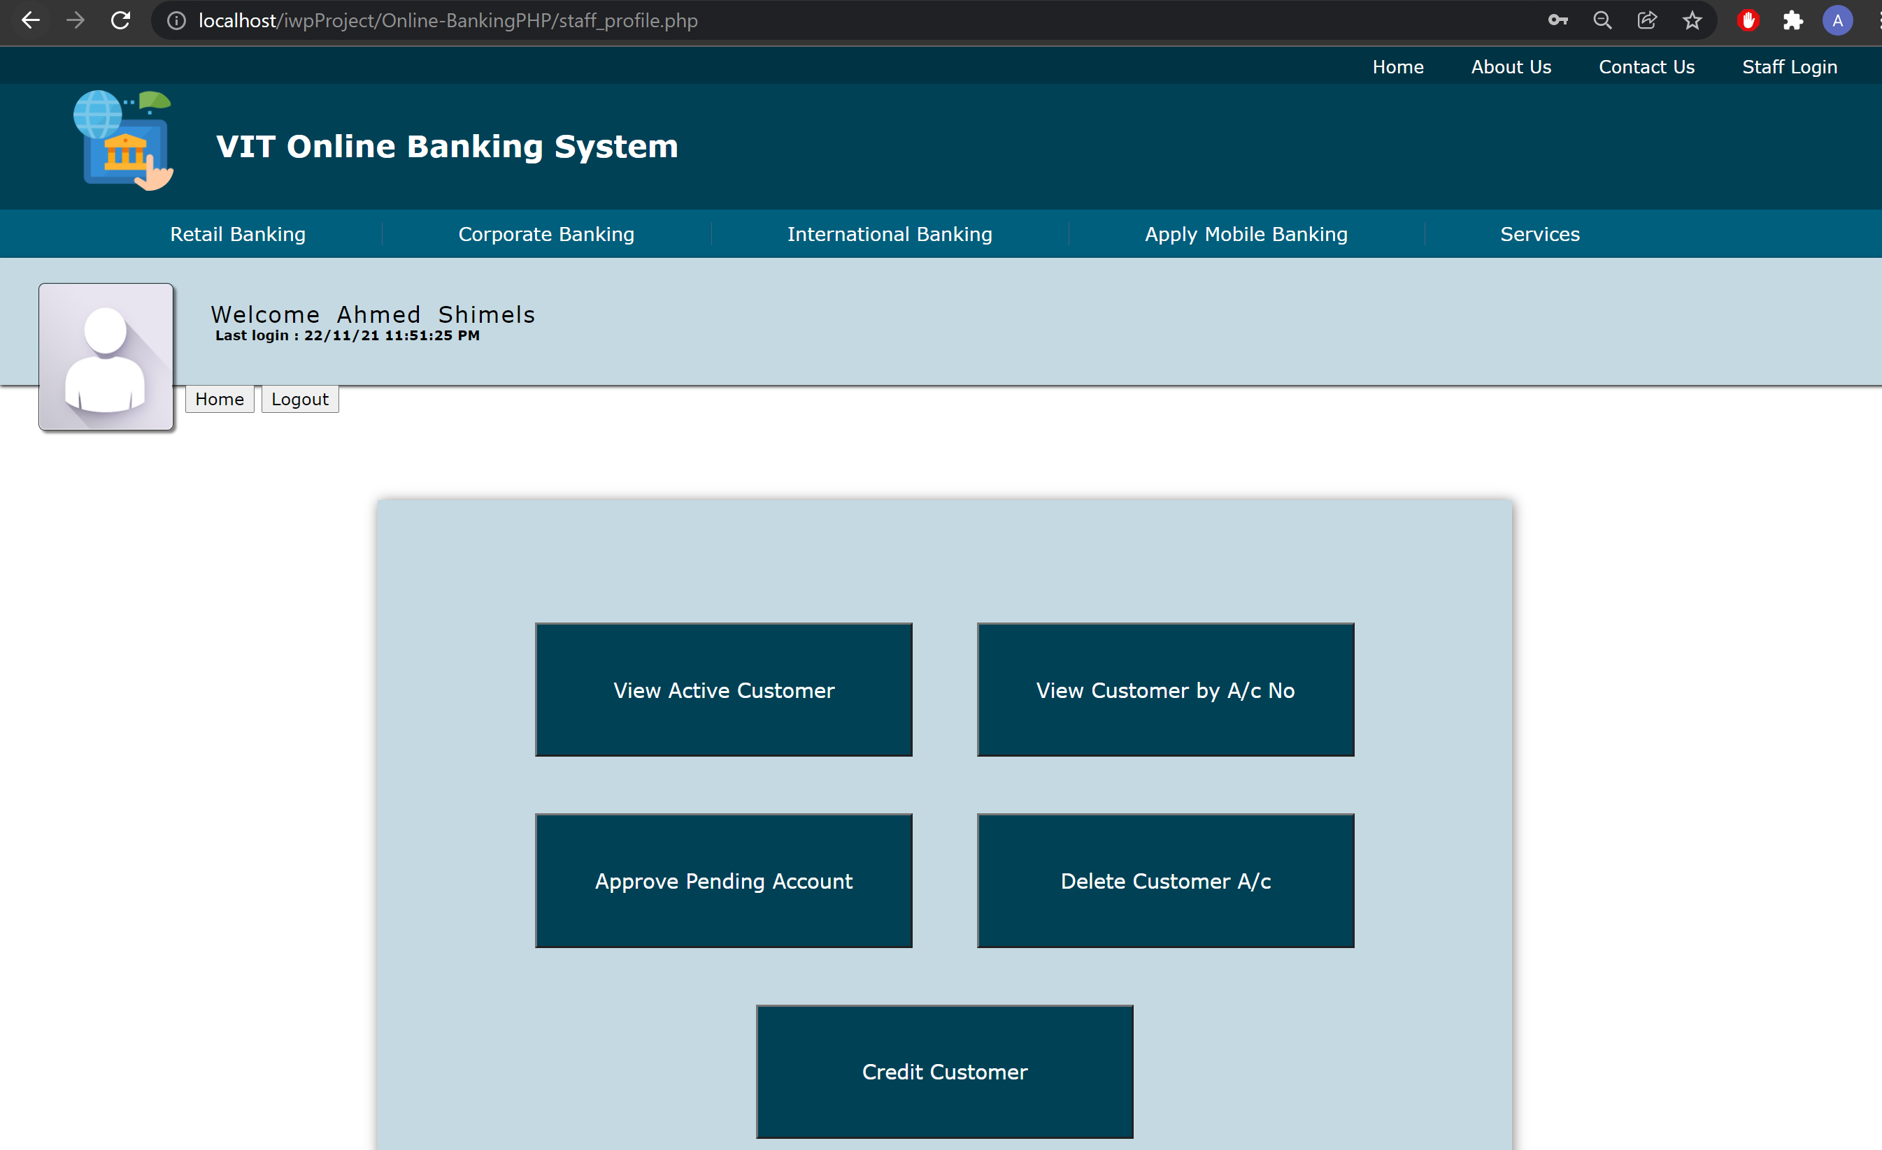

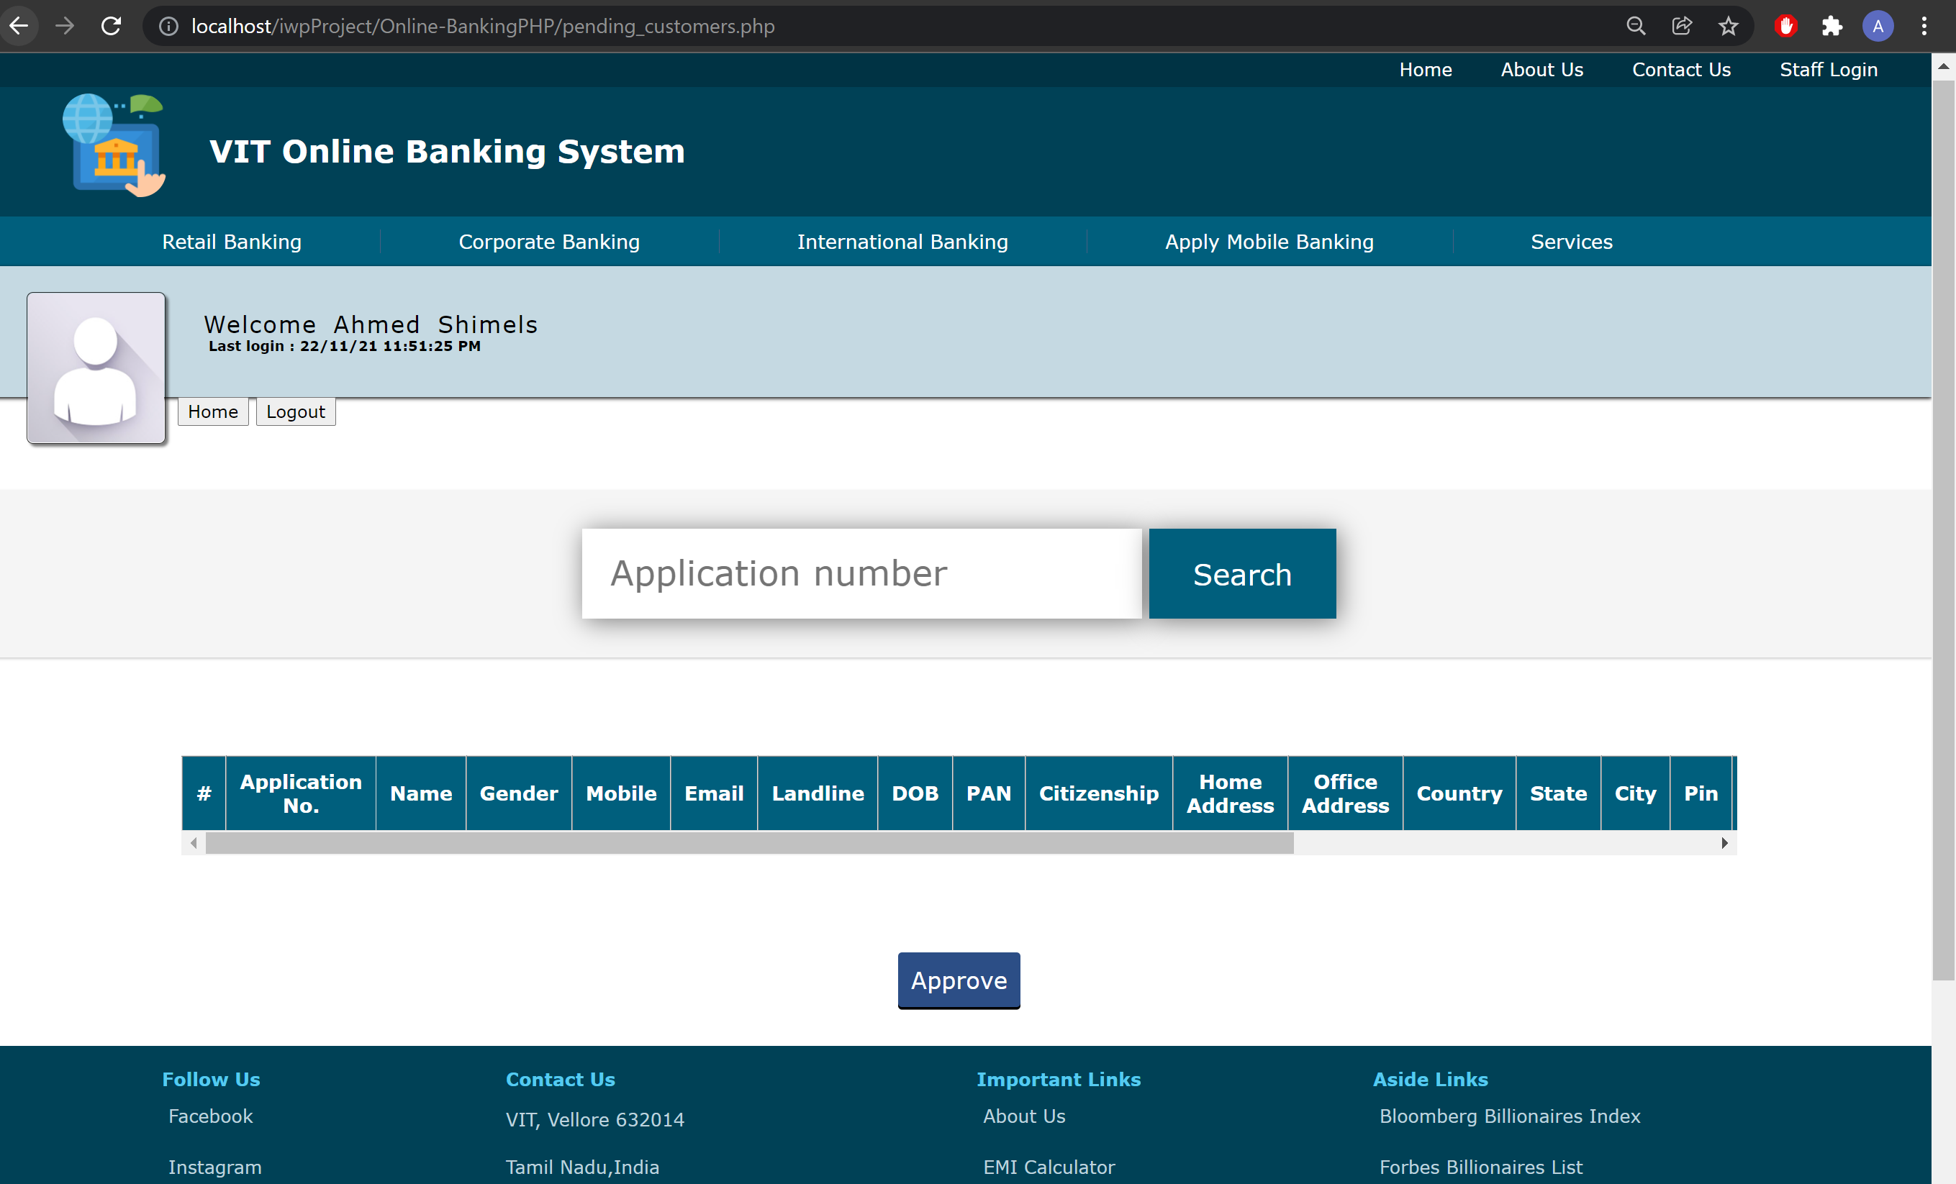

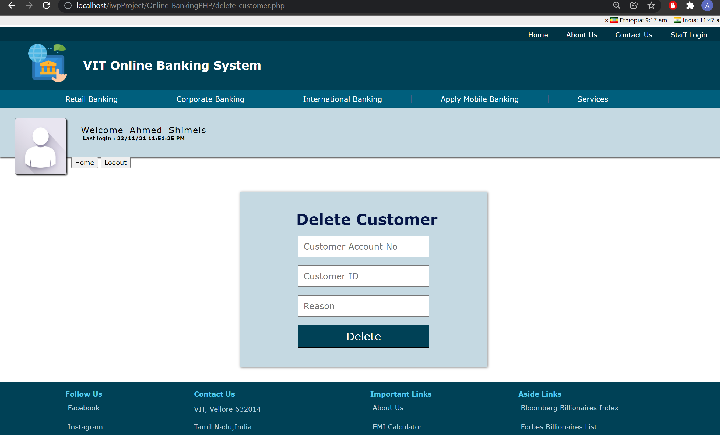

This part is accessible only after the admin logs into his/her account via a “hidden” login page for the admin. There is no other way to access the admin part without logging in first.

It consists of the following core admin features, most of them accessible via a side pane:

* ***Admin Home*** page which serves as a sort of greeting for the customer.
* A ***Post News*** page through which the admin can post news/notices on the home part of the website.
* An ***Add Customer*** page through which the admin can add/create a new customer in the internet baking website database. The add customer form needs to be filled up carefully as any wrong input/data will result in rejection of the form and an appropriate error message will be displayed to the admin.
* The admin holds absolute power over the customer’s details however he/she has no power over the customer’s transactions.
* A ***Manage Customers*** page through which the admin can manage customers of the internet banking website. It has the following features:
  + The customers are displayed in a sequential card layout influenced by the material design. The admin can view/edit/update the details of these customers, view their transactions, or delete them from the database.
  + The admin can search for a particular customer among the list of all the customers by both name and account number.
  1. **Back End: Data base:**

Bank passbook:

each account will have its own respective passbook on the database which records each statement. Besides, the customer can view their account, profile, and change their password. The account section displays all the information related to the bank account whereas the profile section displays all the personal information.

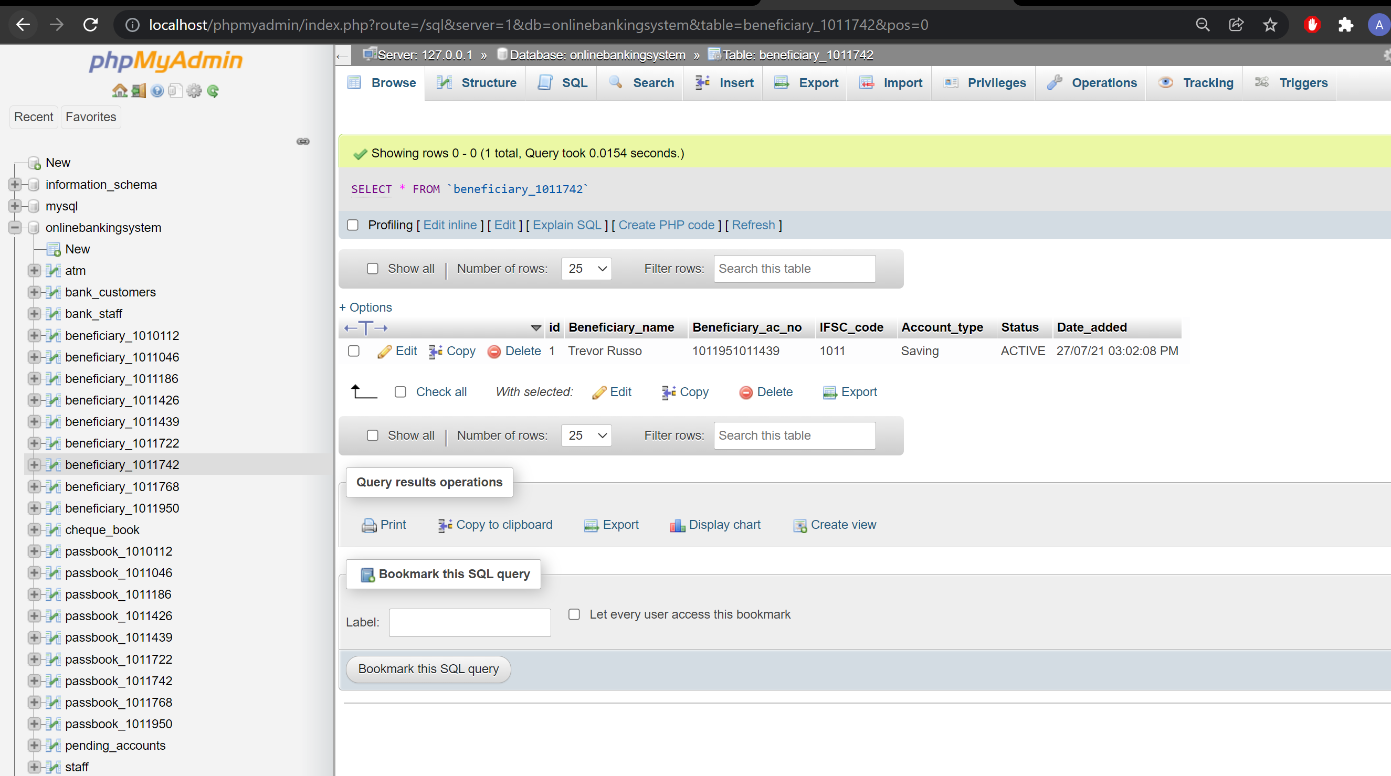

Bank costumers:

Here all the customer detail is available like id number, password, account number &from which state she /he is so the user can see his password and he can log in.

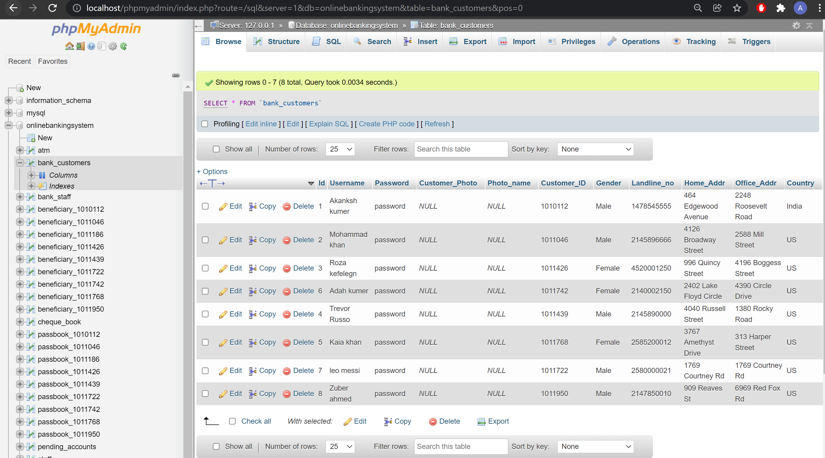

Bank stuff:

Bank stuff he can see the active user and approve what ever the customer apply online in addition to that the stuff can see what ever the customer information like his transaction, whether the user is active or not.

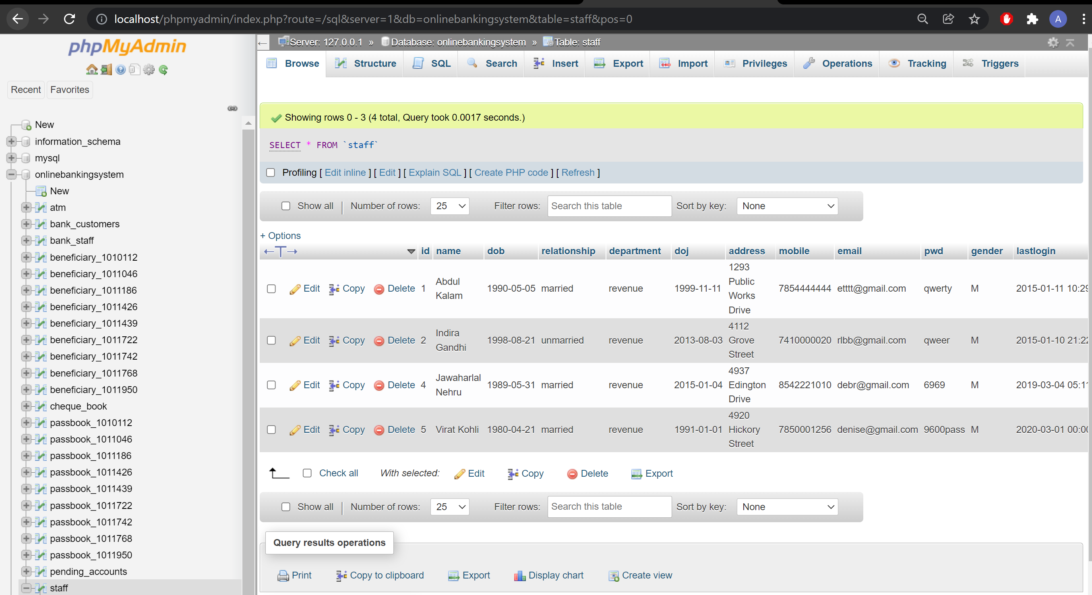

Cheque book:

In cheque book data base, we can see the customer id, account number and cheque_book_status like pending or not.

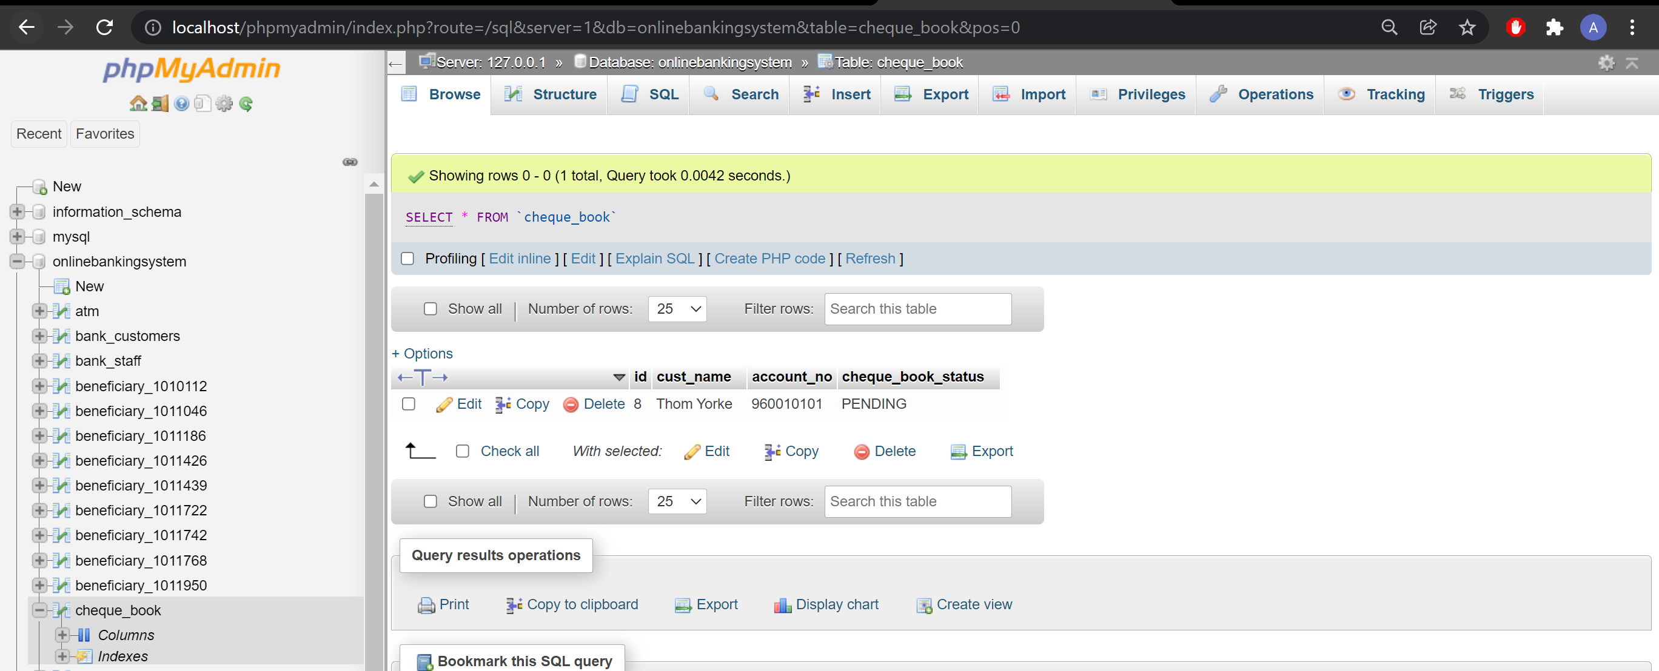

Pending account:

If the stuff is not approving the customer account it shows pending accounts on data base the the staff can approve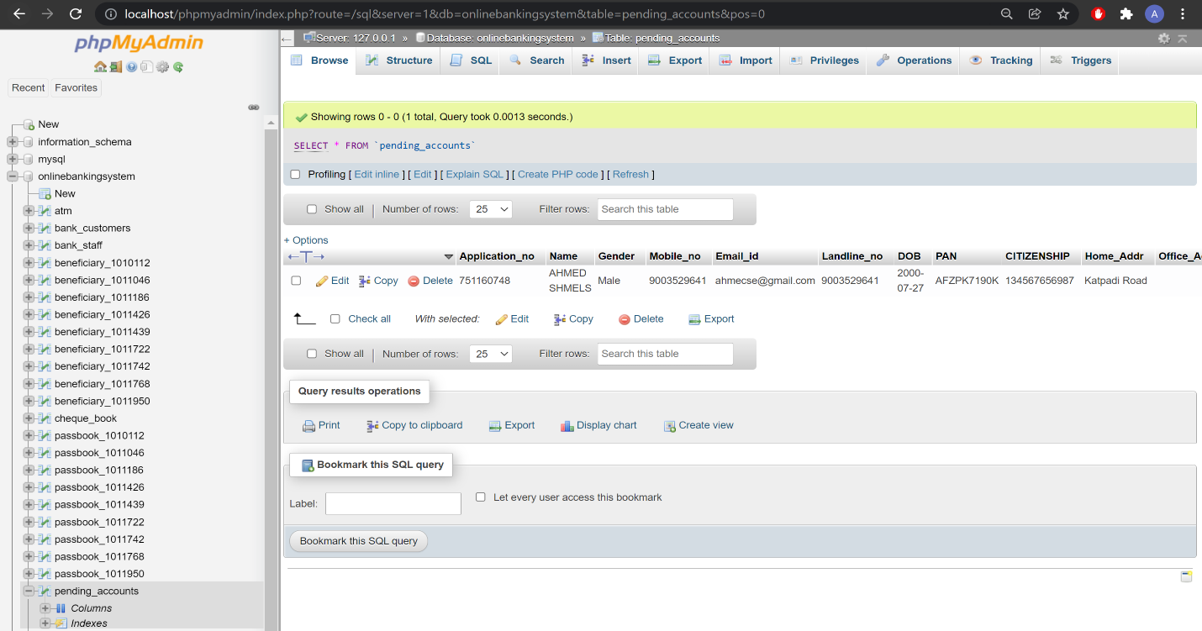.

1. **Implementation and code:**

Index /home page code:

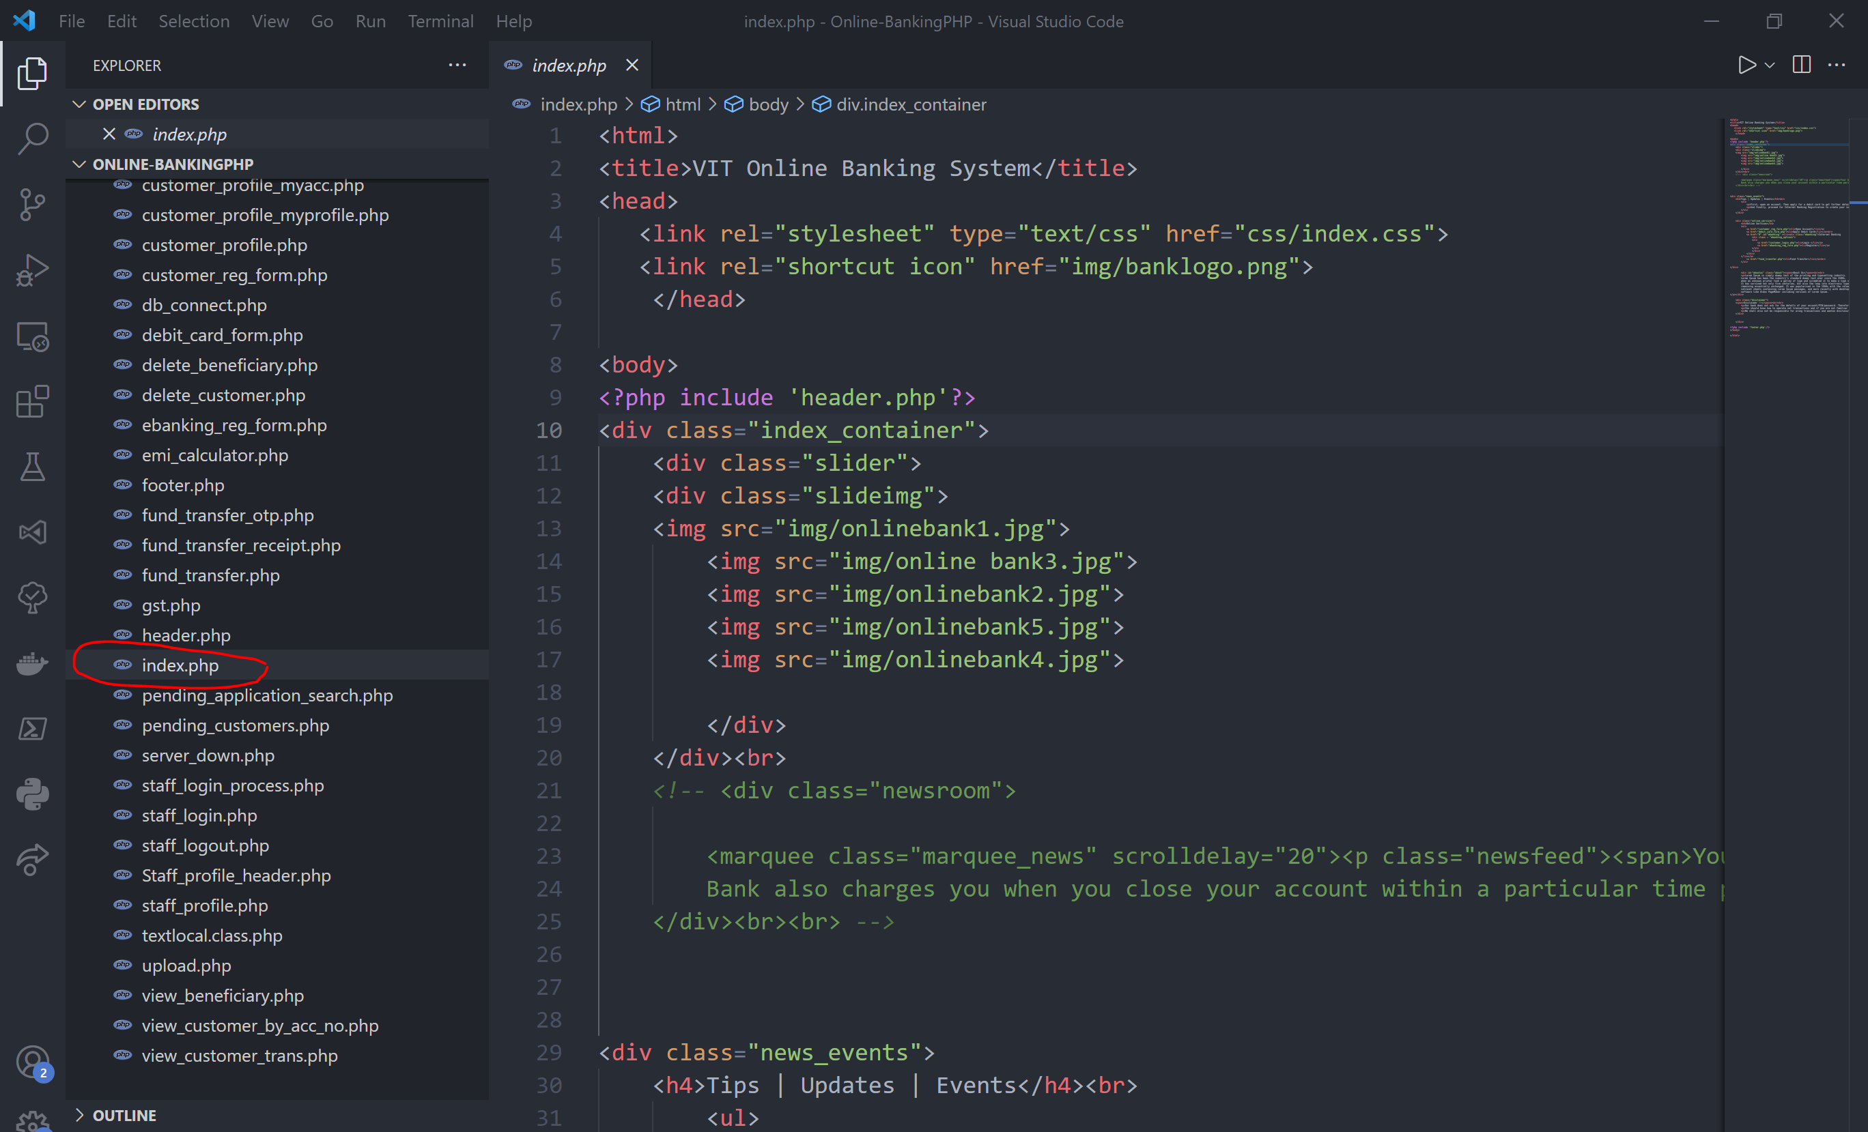

Stuff login page:

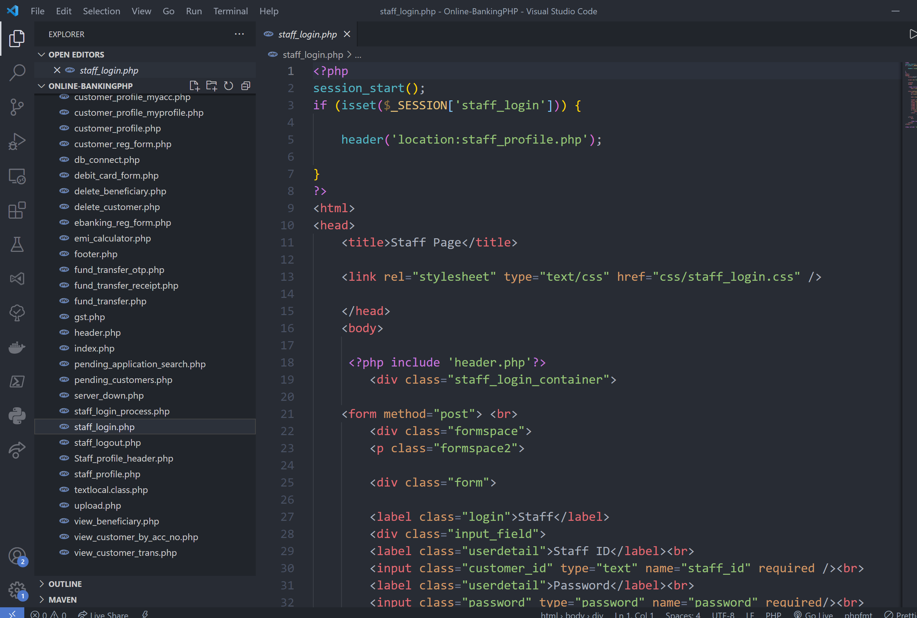

customer login:

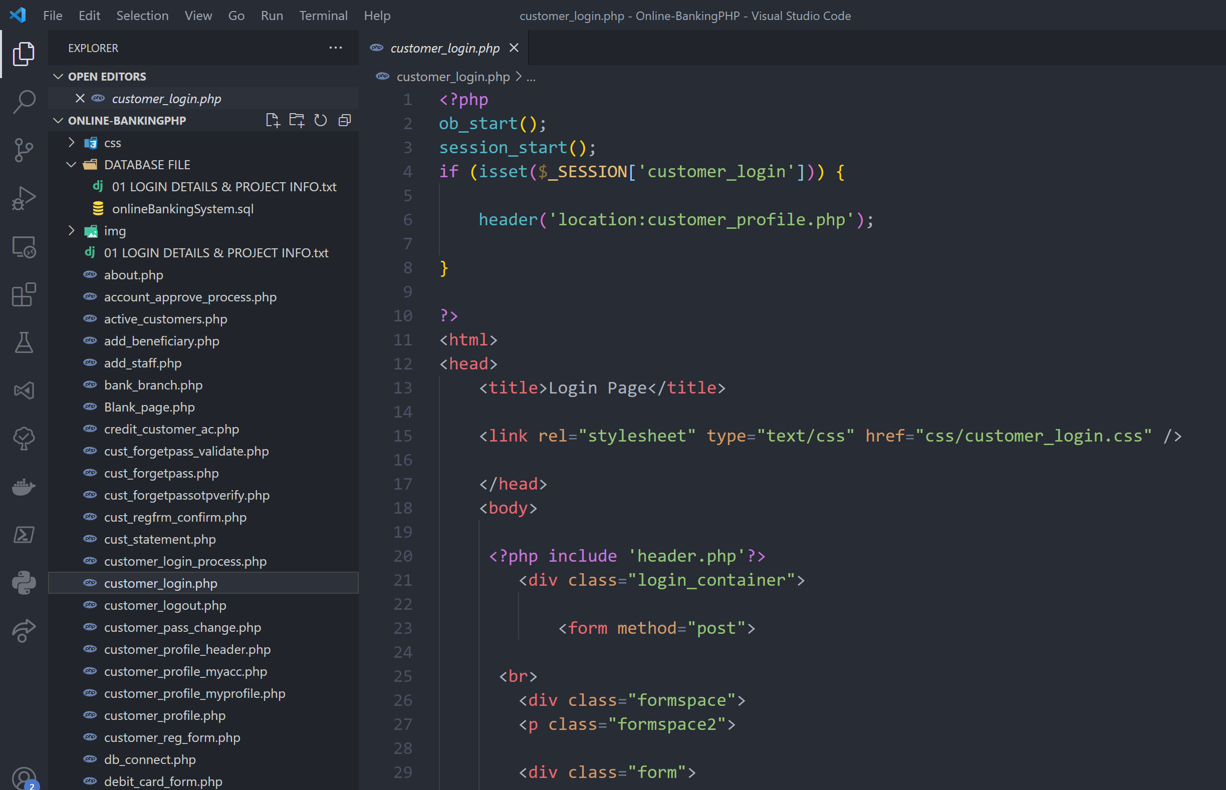

customer registration page:

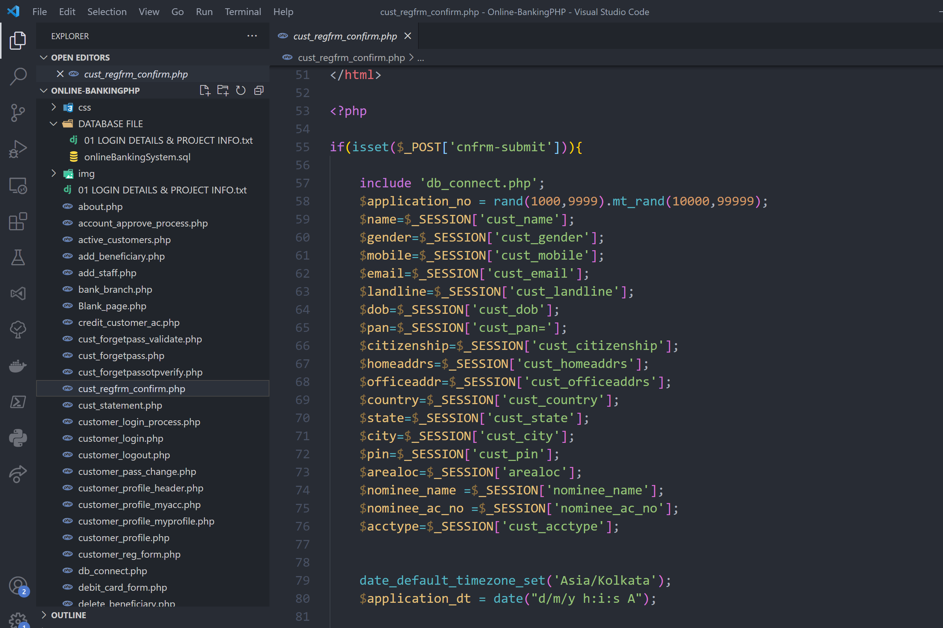

Database:

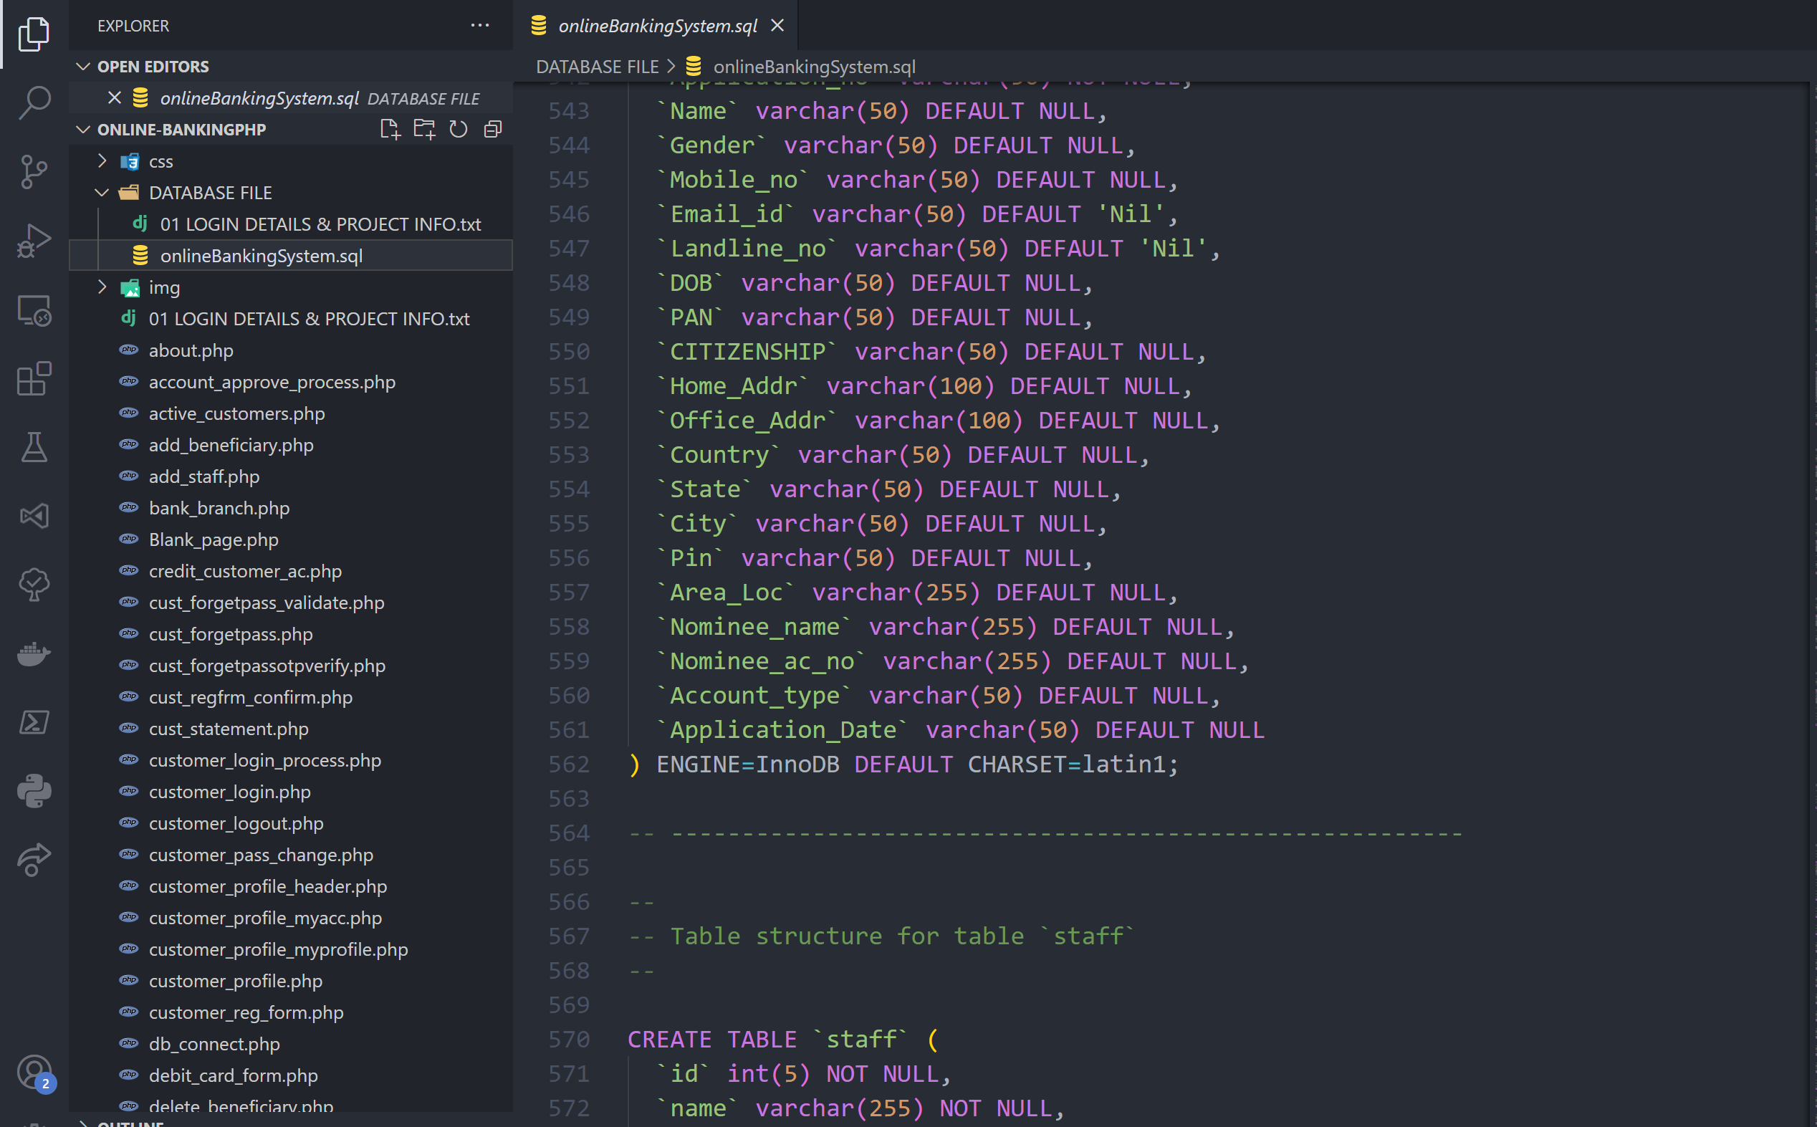

7**.Future Scope of the Project:**

**7.1 Security features of the website**

* Each input is passed through mysqli_real_escape_string () to remove special characters from the string so that user can’t submit arbitrary input. It protects from attacks like SQL Injection and Cross Site Scripting (XSS).
* Sensitive details like password/username in a form are passed through method= “POST” and NOT method= “GET” to prevent leak of such data via the URL.
* Customer/Admin can only enter their accounts after entering their username and password via login.
* Admin login page is hidden from customer for security purposes.
* Before any page of the customer/admin part is displayed/loaded a check is made to ensure that the customer/admin session is valid and active (i.e., whether the customer/admin is logged into his/her session or not). If the session is invalid the user is redirected to the home page without notifying the user.
* Thus, accessing customer/admin pages after logging out, through history/using back button is impossible.
* Customer/Admin can only enter their accounts after entering their username and password via login.
* Admin login page is hidden from customer for security purposes.
* Before any page of the customer/admin part is displayed/loaded a check is made to ensure that the customer/admin session is valid and active (i.e., whether the customer/admin is logged into his/her session or not). If the session is invalid the user is redirected to the home page without notifying the user.
* Thus, accessing customer/admin pages after logging out, through history/using back button is impossible.

**7.2 To do/Future scope:**

* Make a customer grievance system where customer can interact with admin via messages to which the admins can respond appropriately. Much like a mail system between customer and admin.
* Increase security of/on the website and web design, because honestly there is very little security as of now when compared to real world websites.
* Add features/enhance already available features for internet banking.

XML Exercise:

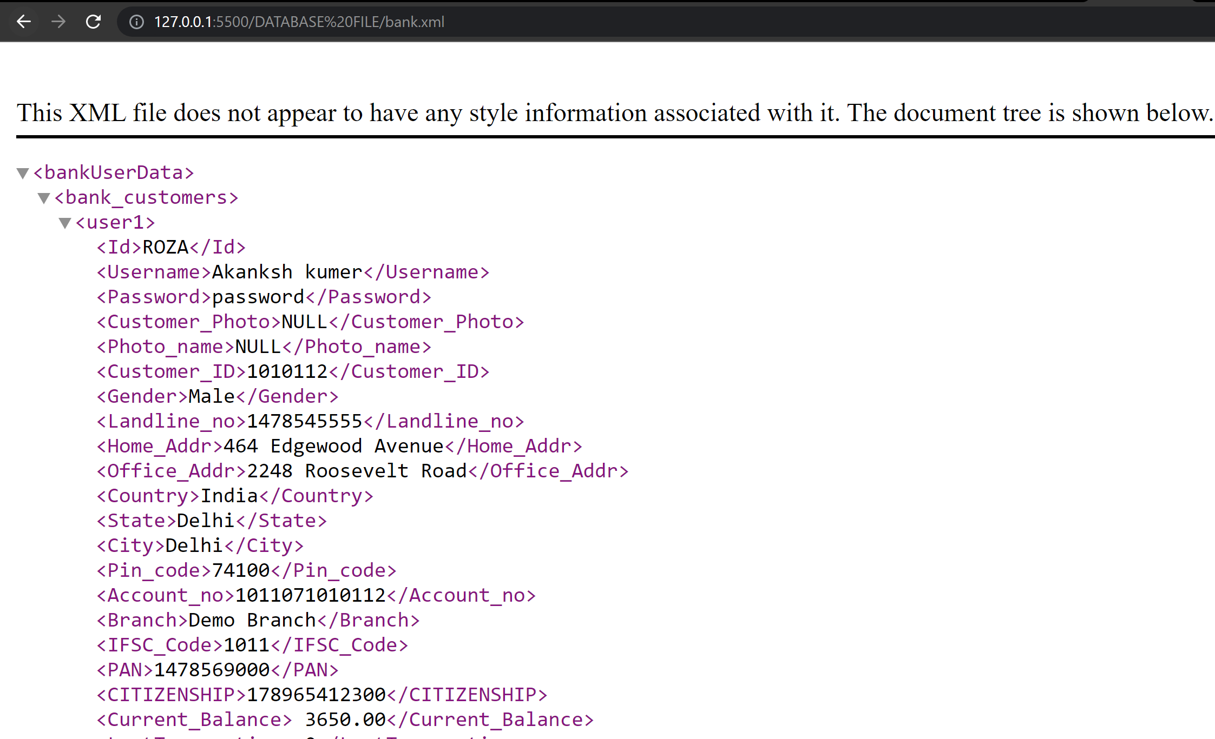

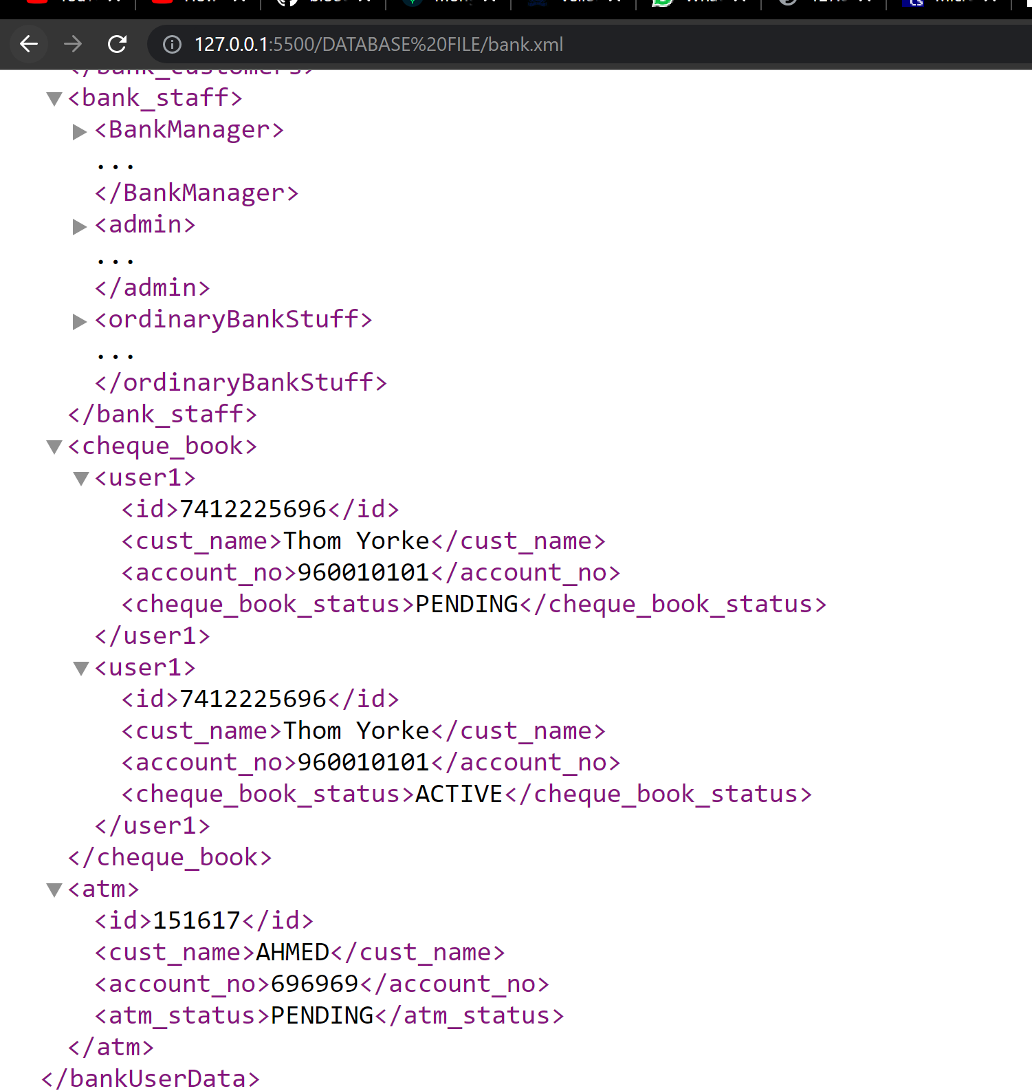

Tree view:

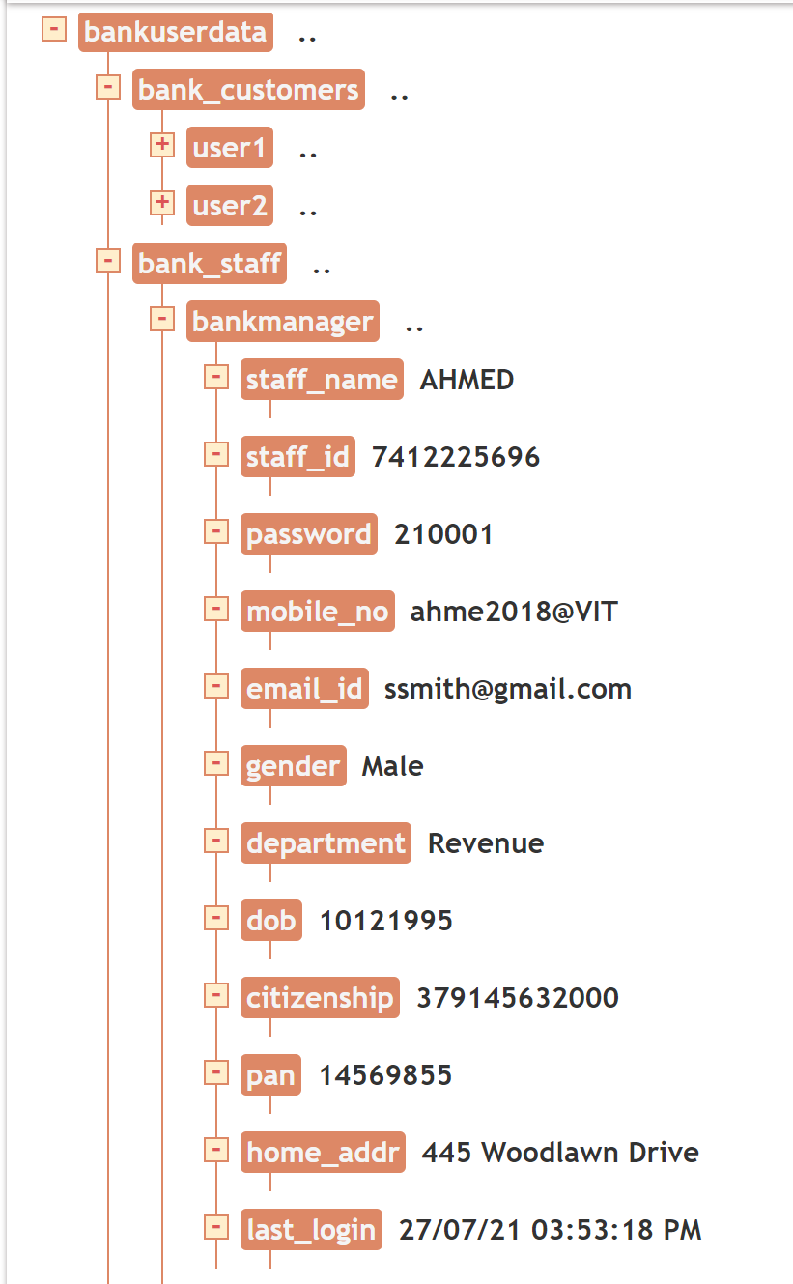

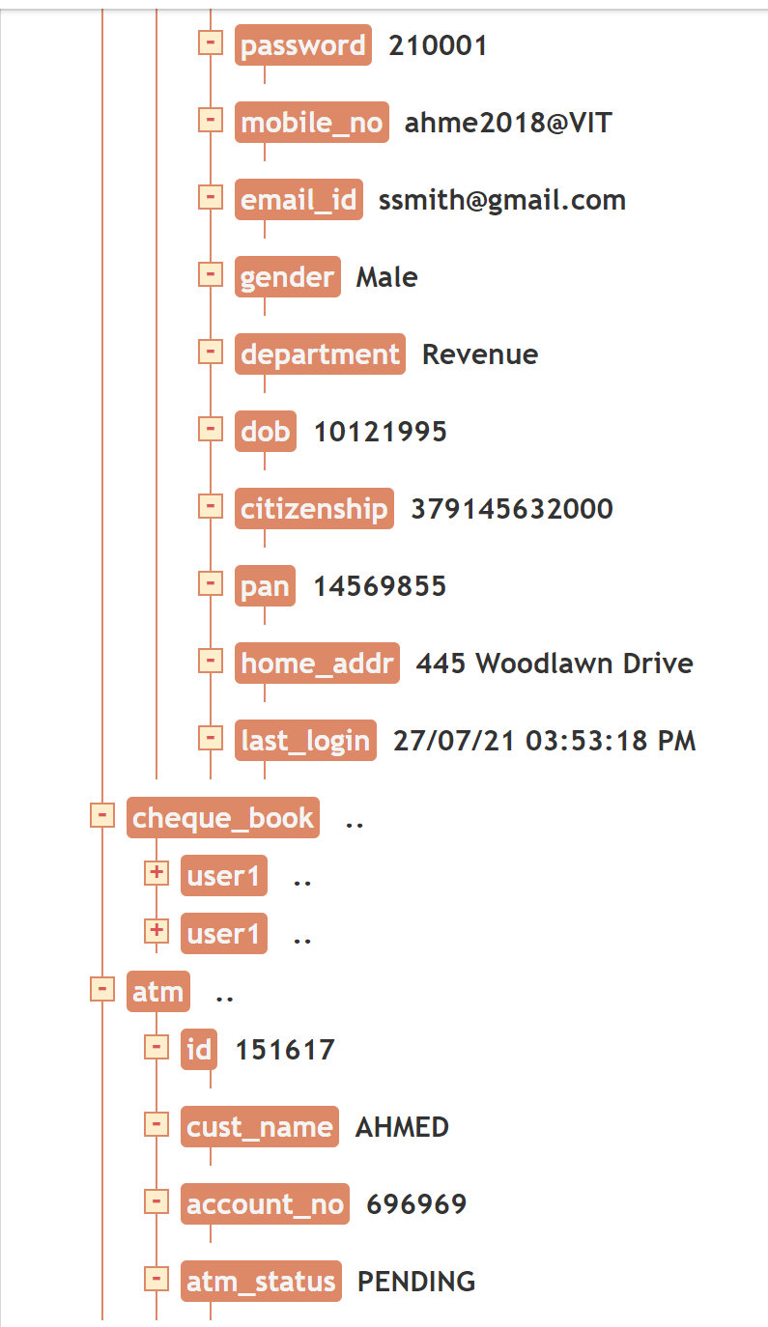

**Connecting the mongo dB:**

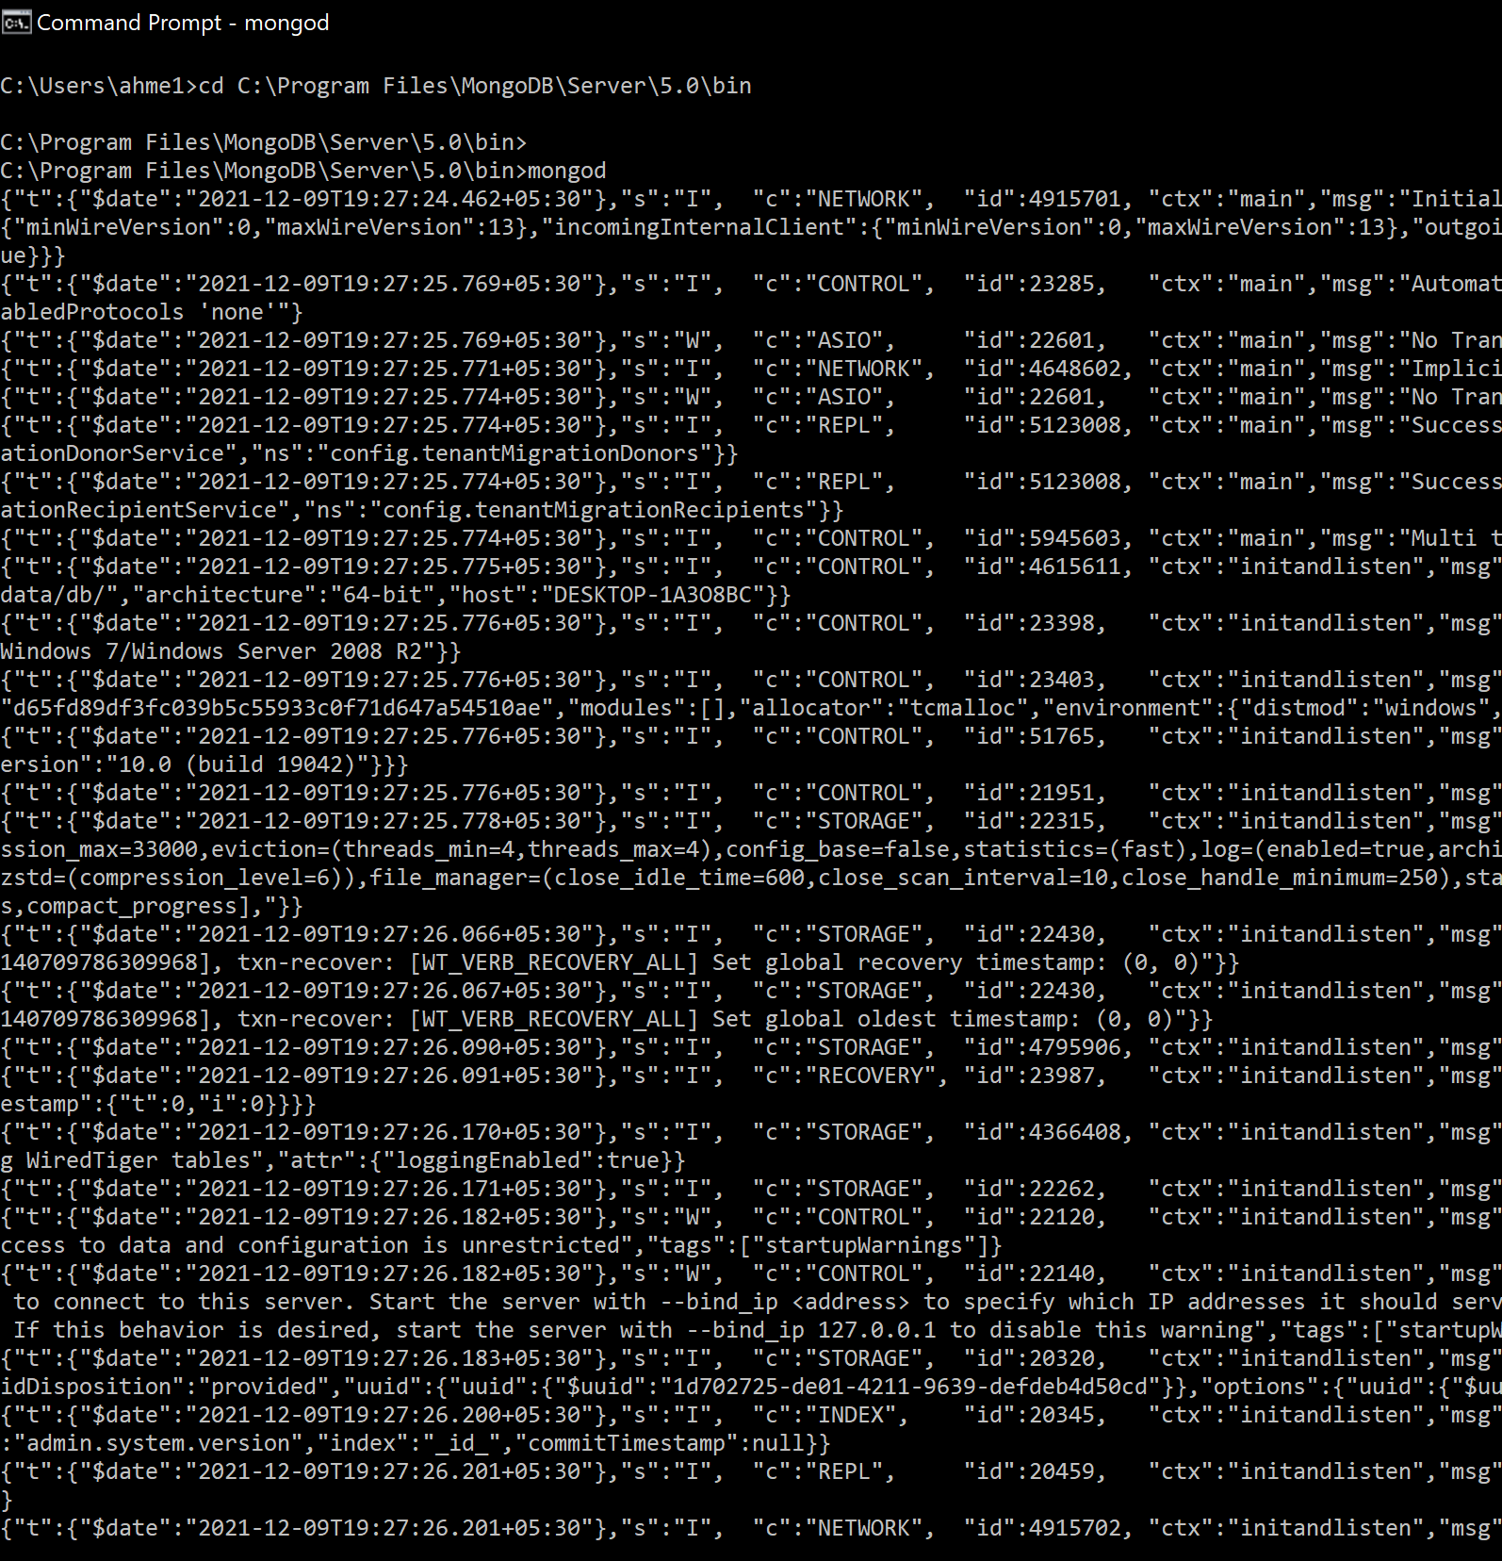

Mongo:

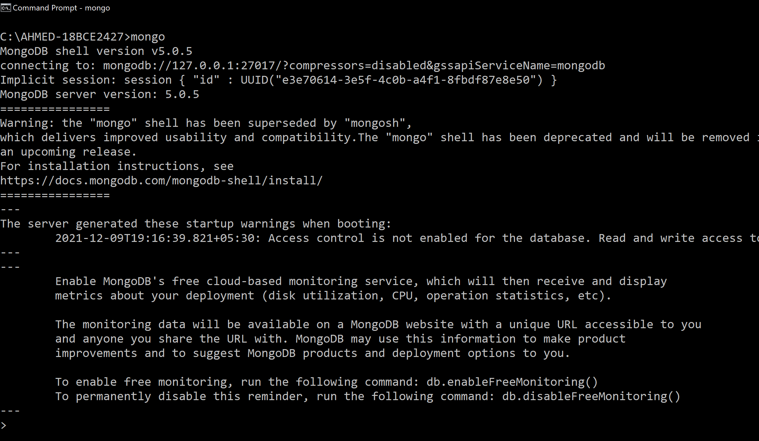

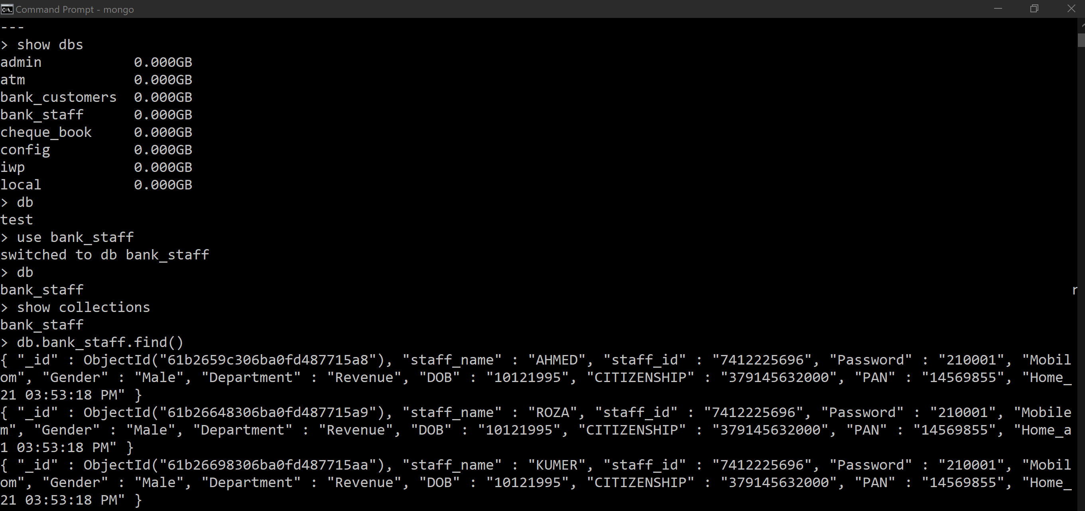

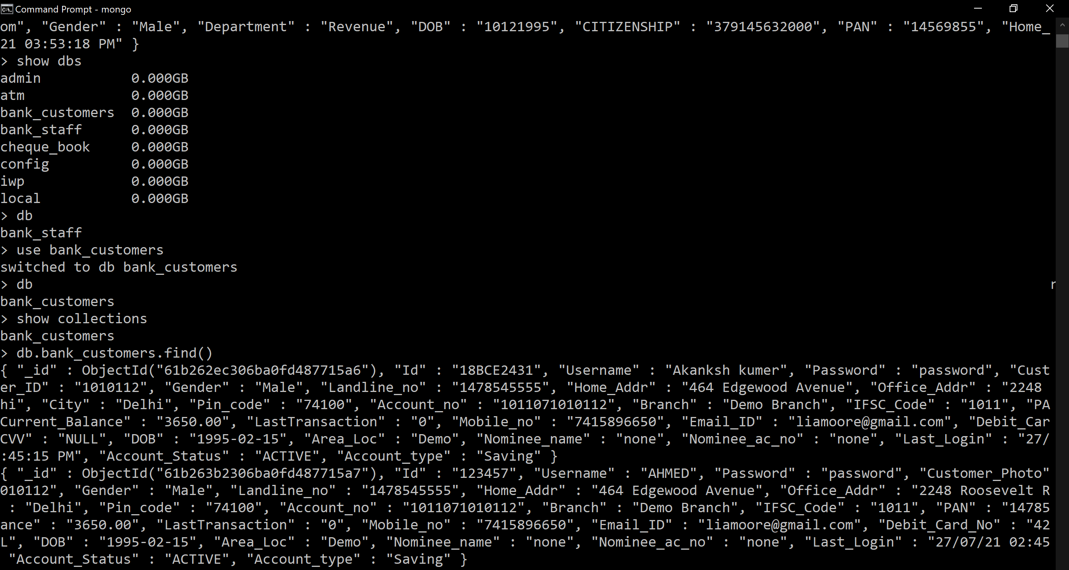

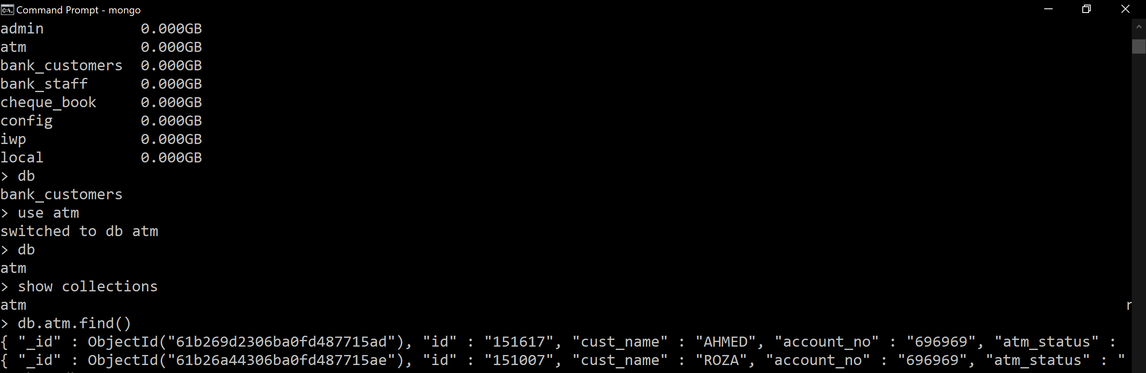

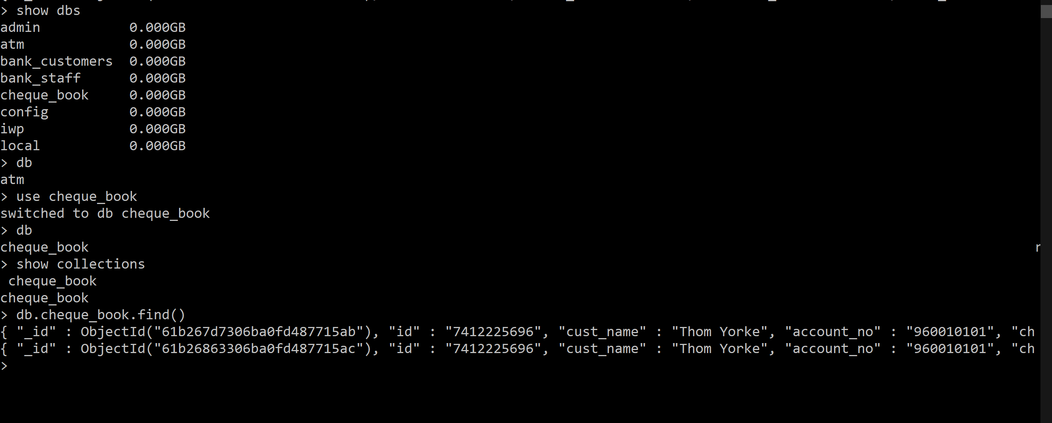

Reference:

1. <https://www.w3schools.com/tags/default.asp>
2. <https://developer.mozilla.org/en-US/docs/Web/CSS/filter>
3. <https://www.w3schools.com/tags/default.asp>
4. <https://developer.mozilla.org/en-US/docs/Web/HTML/Element>
5. <https://css-tricks.com/the-shapes-of-css/>